**Linux-Documentation**

**Chapter 1. The Linux Foundation**

● Introduction

● The Linux Foundation

● Course Linux Requirements

● Knowledge Check (Verified Certificate track only)

● Summary

The families and representative distributions we are using are:

* + - **Red Hat Family Systems** (including **CentOS** and **Fedora**)
    - **SUSE Family Systems** (including **openSUSE**)
    - **Debian Family Systems** (including **Ubuntu** and **Linux Mint**).

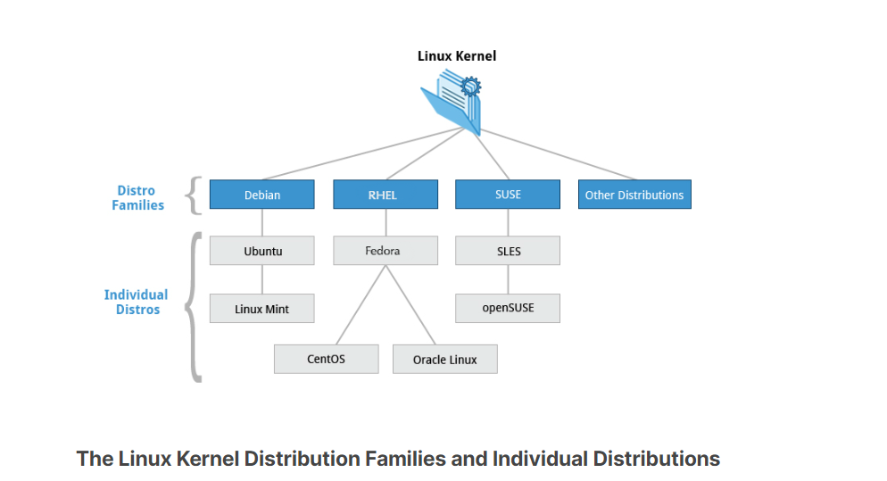

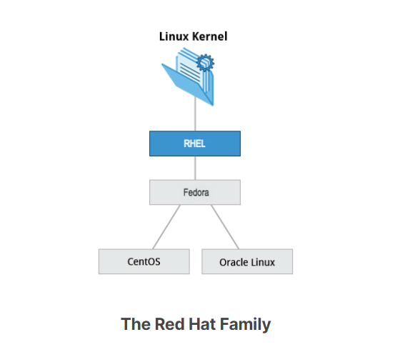

Some of the key facts about the Red Hat distribution family are:

* + - Fedora serves as an upstream testing platform for RHEL.
    - CentOS is a close clone of RHEL, while Oracle Linux is mostly a copy with some changes (in fact, CentOS has been part of Red Hat since 2014).
    - A heavily patched version 3.10 kernel is used in RHEL/CentOS 7, while version 4.18 is used in RHEL/CentOS 8.
    - It supports hardware platforms such as Intel x86, Arm, Itanium, PowerPC, and IBM System z.
    - It uses the yum and dnf RPM-based yum package managers (covered in detail later) to install, update, and remove packages in the system.
    - RHEL is widely used by enterprises which host their own systems.

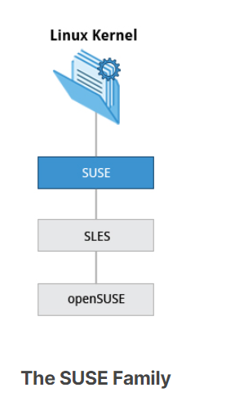

Some of the key facts about the SUSE family are listed below:

* + - SUSE Linux Enterprise Server (SLES) is upstream for openSUSE.
    - Kernel version 4.12 is used in openSUSE Leap 15.
    - It uses the RPM-based zypper package manager (we cover it in detail later) to install, update, and remove packages in the system.
    - It includes the YaST (Yet Another Setup Tool) application for system administration purposes.
    - SLES is widely used in retail and many other sectors.

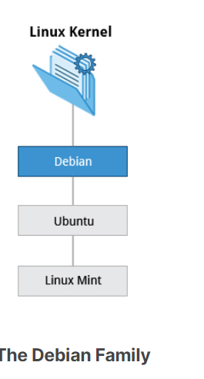

Some key facts about the Debian family are listed below:

* + - The Debian family is upstream for Ubuntu, and Ubuntu is upstream for Linux Mint and others.
    - Kernel version 5.8 is used in Ubuntu 20.04 LTS.
    - It uses the DPKG-based APT package manager (using apt, apt-get, apt-cache, etc., which we cover in detail later) to install, update, and remove packages in the system.
    - Ubuntu has been widely used for cloud deployments.
    - While Ubuntu is built on top of Debian and is GNOME-based under the hood, it differs visually from the interface on standard Debian, as well as other distributions.

**Linux-History:**

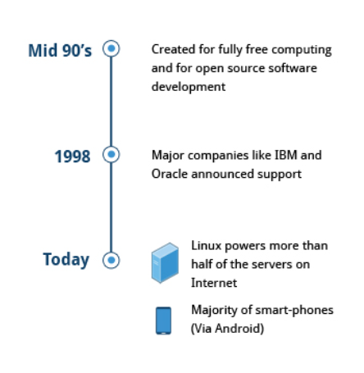

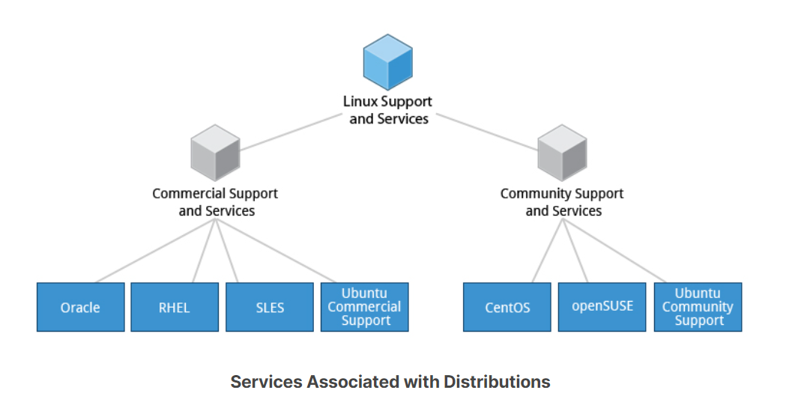

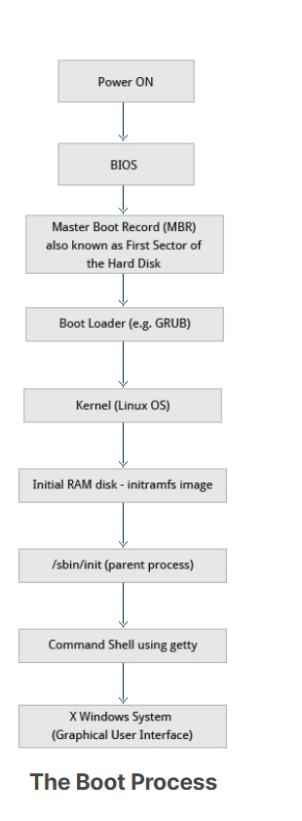

k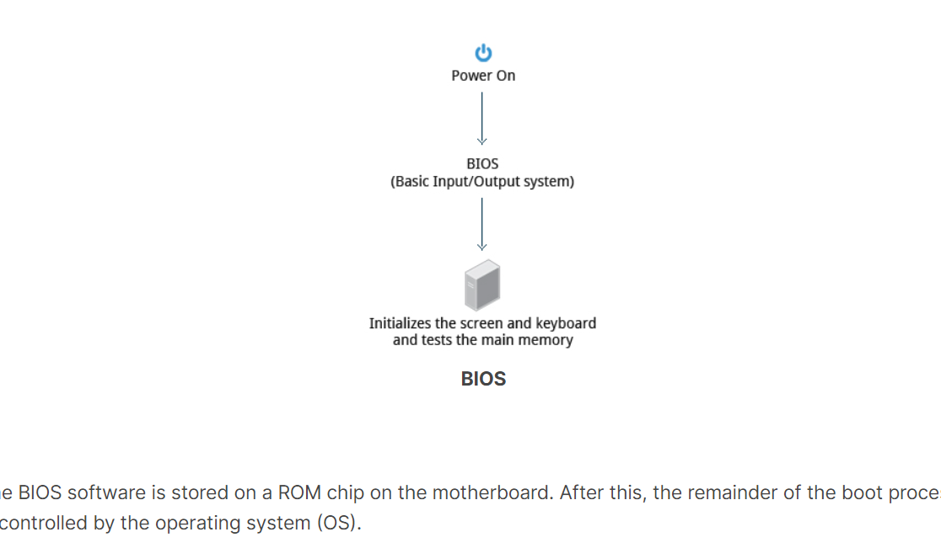

A number of boot loaders exist for Linux; the most common ones are **GRUB** (for **GR**and **U**nified **B**oot loader), **ISOLINUX** (for booting from removable media), and **DAS U-Boot** (for booting on embedded devices/appliances)

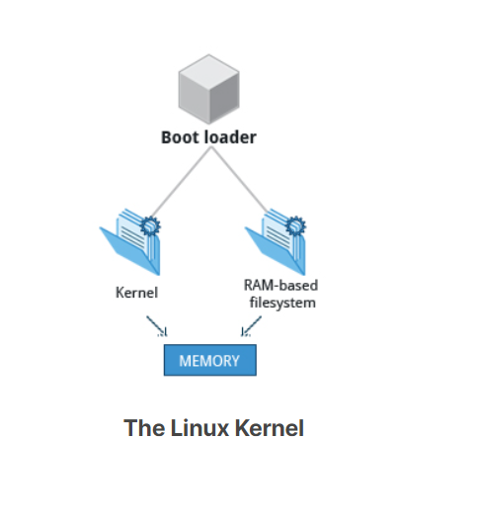

Kl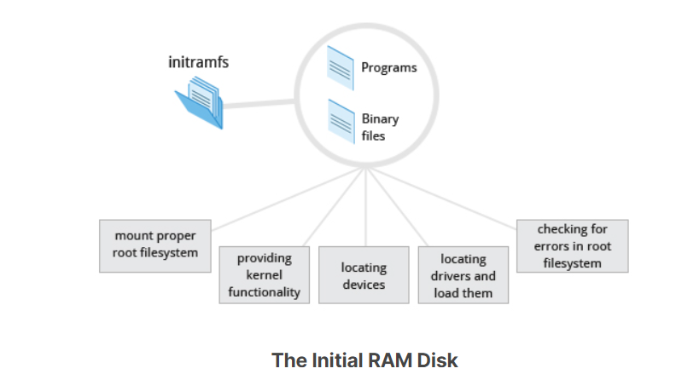

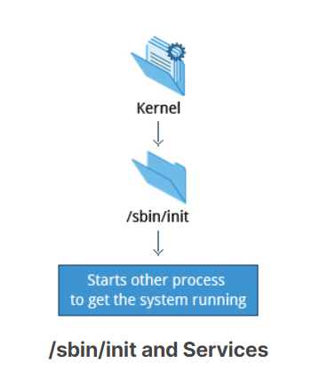

Besides starting the system, **init** is responsible for keeping the system running and for shutting it down cleanly.

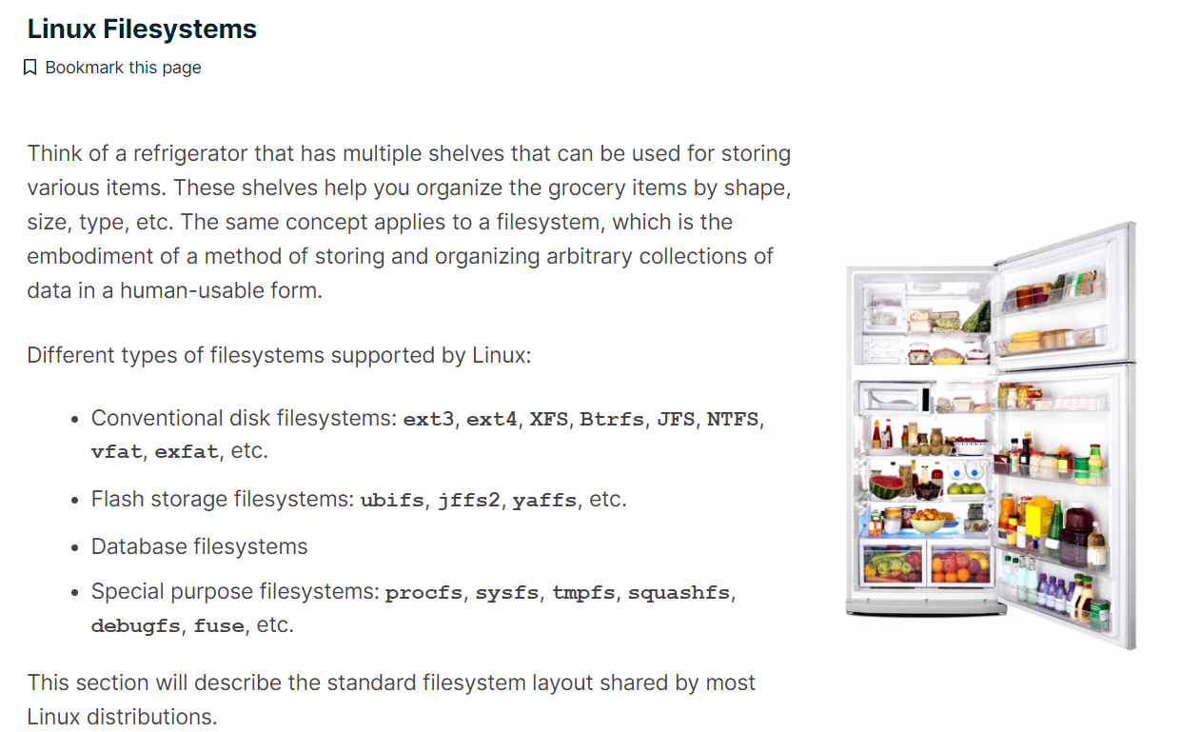

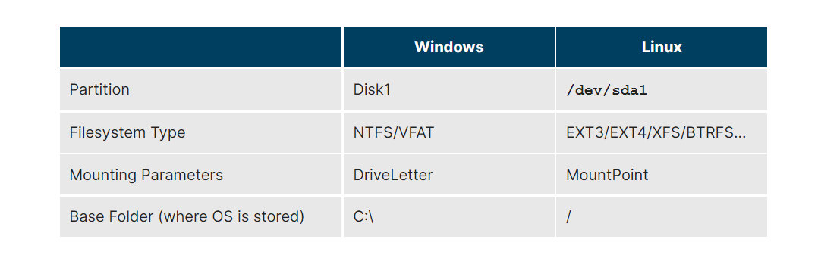

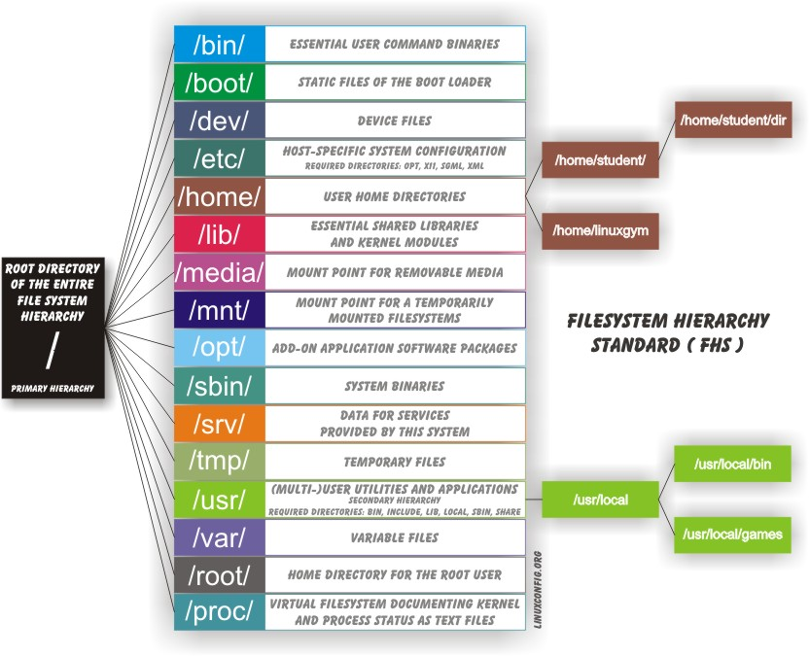

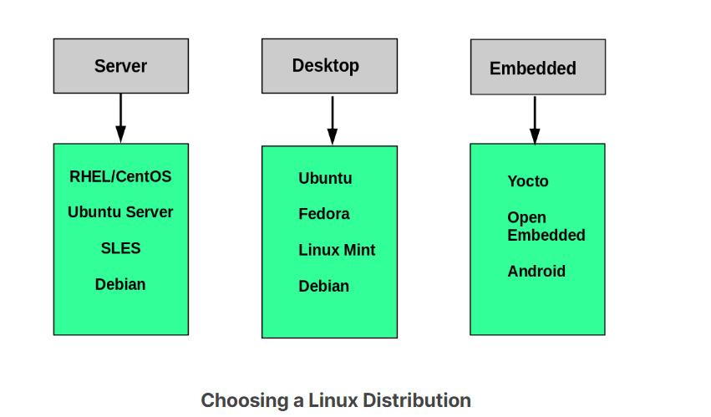

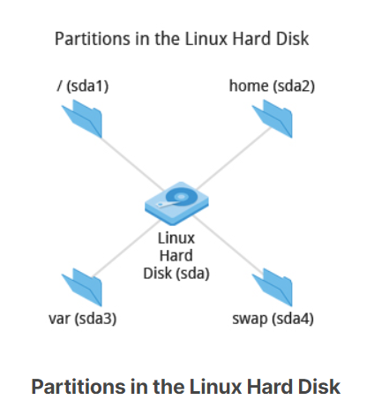

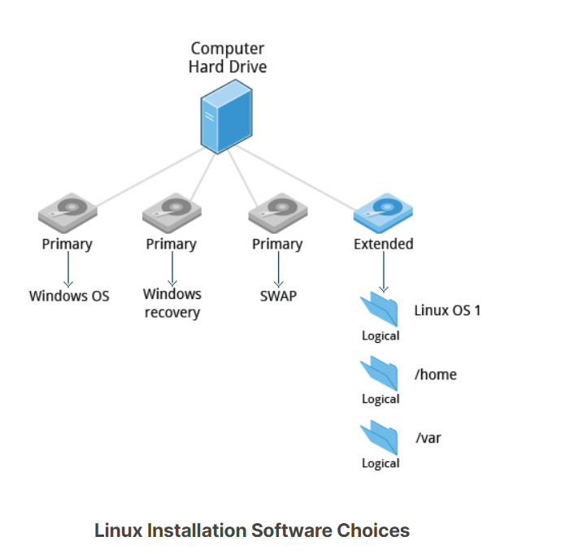

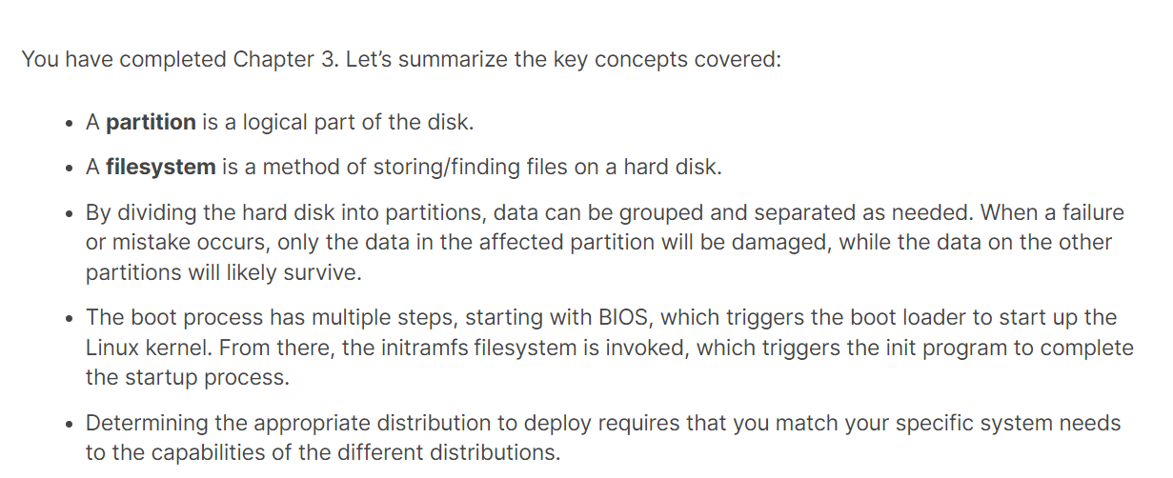

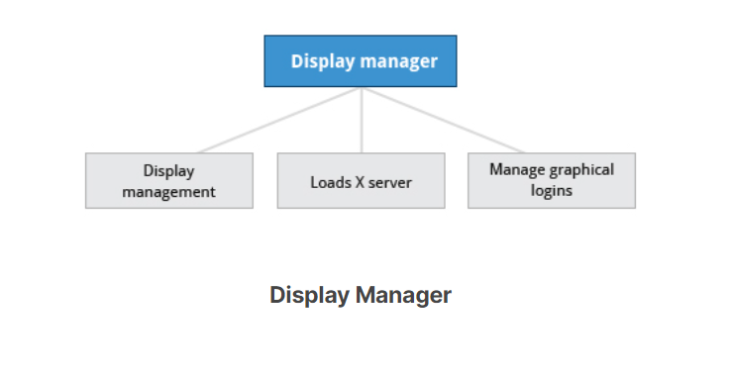

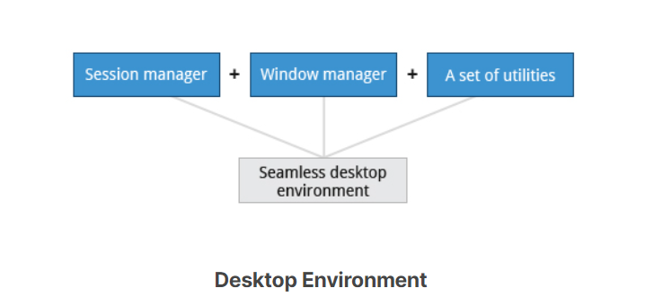

The default display manager for GNOME is called **gdm**. Other popular display managers include **lightdm** (used on Ubuntu before version 18.04 LTS) and **kdm** (associated with KDE).

You have completed Chapter 4. Let's summarize the key concepts covered:

* + - * + **GNOME** is a popular desktop environment and graphical user interface that runs on top of the Linux operating system.
        + The default display manager for GNOME is called **gdm**.
        + The gdm display manager presents the user with the login screen, which prompts for the login username and password.
        + Logging out through the desktop environment kills all processes in your current **X** session and returns to the display manager login screen.
        + Linux enables users to switch between logged-in sessions.
        + Suspending puts the computer into sleep mode.
        + For each key task, there is generally a default application installed.
        + Every user created in the system will have a **home** directory.
        + The *Places* menu contains entries that allow you to access different parts of the computer and the network.
        + **Nautilus** gives three formats to view files.
        + Most text editors are located in the *Accessories* submenu.
        + Each Linux distribution comes with its own set of desktop backgrounds.
        + GNOME comes with a set of different themes which can change the way your applications look.



You have completed Chapter 5. Let's summarize the key concepts covered:

* + - You can control basic configuration options and desktop settings through the *System Settings* panel.
    - Linux always uses Coordinated Universal Time (UTC) for its own internal time-keeping. You can set the date and time settings from the *System Settings* window.
    - The Network Time Protocol is the most popular and reliable protocol for setting the local time via Internet servers.
    - The *Displays* panel allows you to change the resolution of your display and configure multiple screens.
    - Network Manager can present available wireless networks, allow the choice of a wireless or mobile broadband network, handle passwords, and set up VPNs.
    - **dpkg** and **RPM** are the most popular package management systems used on Linux distributions.
    - Debian distributions use **dpkg** and **apt**-based utilities for package management.
    - RPM was developed by Red Hat, and adopted by a number of other distributions, including the openSUSE, Mandriva, CentOS, Oracle Linux, and others.

**Applications of Linux:**

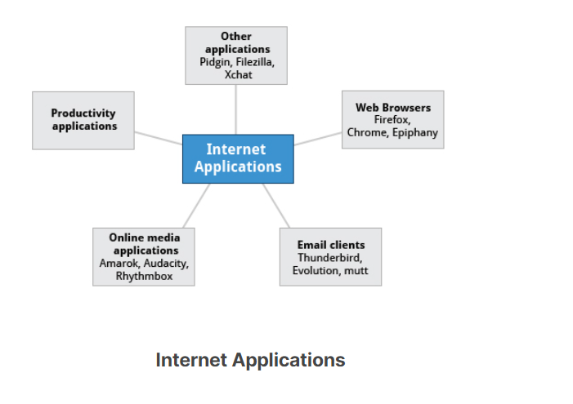

**Web Browsers:**

* Firefox
* Google Chrome
* Chromium
* Epiphany (renamed web)
* Konqueror
* linx, lynx, w3m
* Opera

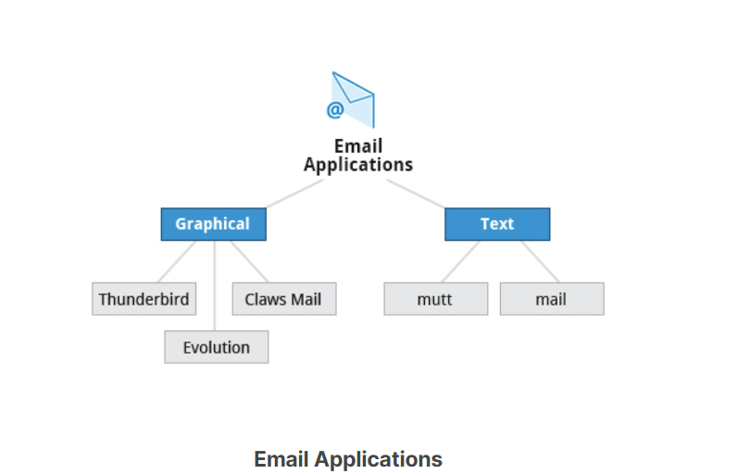

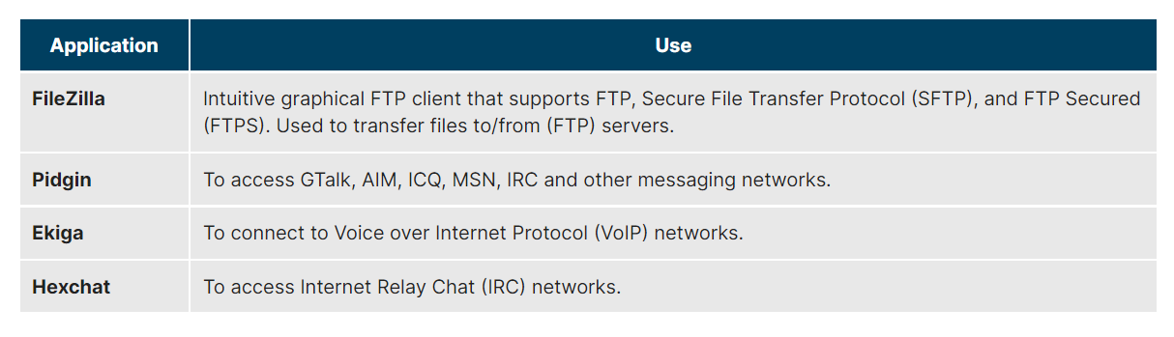

* Text (articles, books, reports, etc.)
* Spreadsheets
* Presentations
* Graphical objects.

The component applications included in LibreOffice are:

* + - Writer: Word Processing
    - Calc: Spreadsheets
    - Impress: Presentations
    - Draw: Create and edit graphics and diagrams.



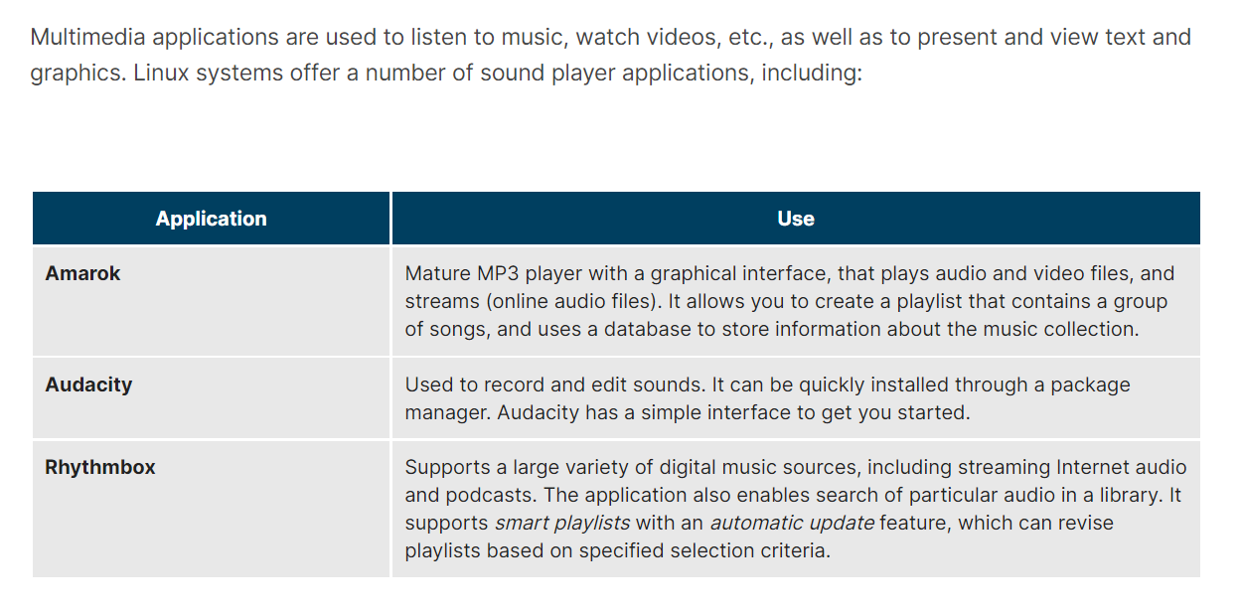

Linux systems offer a number of movie players, including:

* + - VLC
    - MPlayer
    - Xine
    - Totem
* Linux offers a wide variety of Internet applications, such as web browsers, email clients, online media applications, and others.
* Web browsers supported by Linux can be either graphical or text-based, such as Firefox, Google Chrome, Epiphany, w3m, lynx, and others.
* Linux supports graphical email clients, such as Thunderbird, Evolution, and Claws Mail, and text mode email clients, such as Mutt and mail.
* Linux systems provide many other applications for performing Internet-related tasks, such as Filezilla, XChat, Pidgin, and others.
* Most Linux distributions offer LibreOffice to create and edit different kinds of documents.
* Linux systems offer entire suites of development applications and tools, including compilers and debuggers.
* Linux systems offer a number of sound players including Amarok, Audacity, and Rhythmbox.
* Linux systems offer a number of movie players, including VLC, MPlayer, Xine, and Totem.
* Linux systems offer a number of movie editors, including Kino, Cinepaint, Blender among others.
* The GIMP (GNU Image Manipulation Program) utility is a feature-rich image retouching and editing tool available on all Linux distributions.
* Other graphics utilities that help perform various image-related tasks are eog, Inkscape, convert, and Scribus.

**Basics Command:**

* **cat**: used to type out a file (or combine files).
* **head**: used to show the first few lines of a file.
* **tail**: used to show the last few lines of a file.
* **man**: used to view documentation.

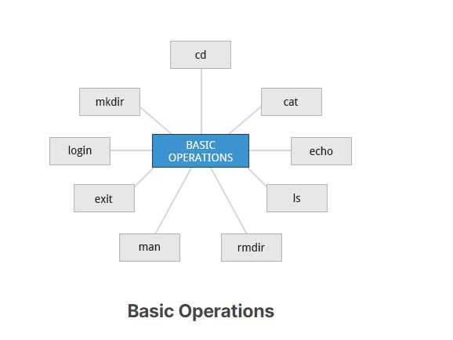

* Once your session is started (either by logging into a text terminal or via a graphical terminal program), you can also connect and log into remote systems by using **S**ecure **SH**ell (SSH). For example, by typing **ssh student@remote-server.com**, SSH would connect securely to the remote machine (**remote-server.com**)
* When administering a multi-user system, you have the option of notifying all users prior to shutdown, as in:
* **$ sudo shutdown -h 10:00 "Shutting down for scheduled maintenance."**
* **$ shutdown –c to cancel the shutdown**

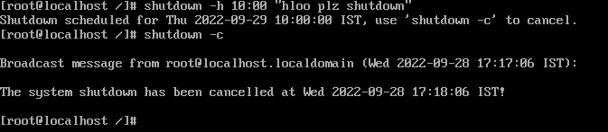

* In general, executable programs and scripts should live in the **/bin**, **/usr/bin**, **/sbin**, **/usr/sbin** directories, or somewhere under **/opt**. They can also appear in **/usr/local/bin** and **/usr/local/sbin**, or in a directory in a user's account space, such as **/home/student/bin**.
* One way to locate programs is to employ the which utility. For example, to find out exactly where the diff program resides on the filesystem:
* **$ which diff**  
  **/usr/bin/diff**
* If **which** does not find the program, **whereis** is a good alternative because it looks for packages in a broader range of system directories:
* **$ whereis diff**  
  **diff: /usr/bin/diff /usr/share/man/man1/diff.1.gz /usr/share/man/man1p/diff.1p.gz**
* as well as locating source and **man** files packaged with the program.

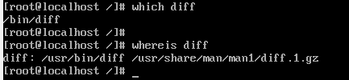

* When you first log into a system or open a terminal, the default directory should be your home directory. You can print the exact path of this by typing **echo $HOME**.

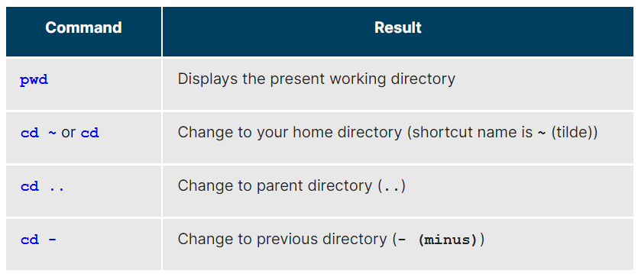

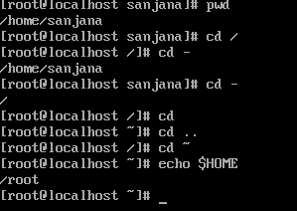

* Pushd pushes the location into stack the directing to that path
* Popd will goes to the location present on the top of the stack by removing the entry in the stack.

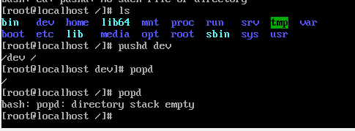

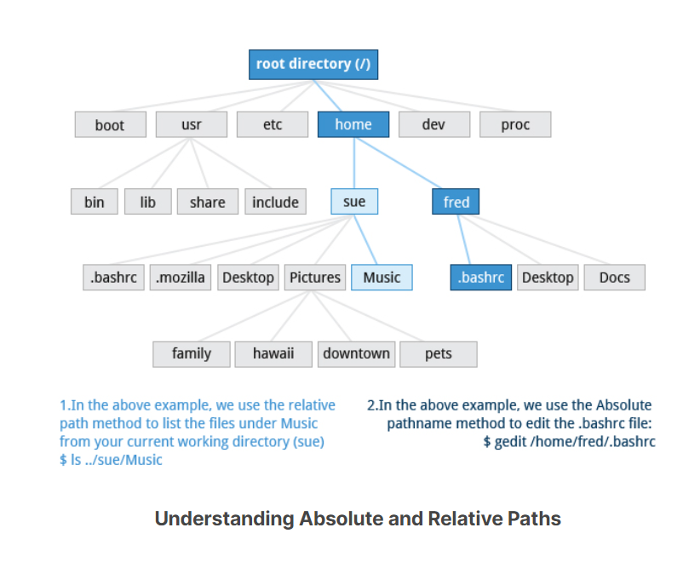

* Traversing up and down the filesystem tree can get tedious. The **tree** command is a good way to get a bird’s-eye view of the filesystem tree. Use

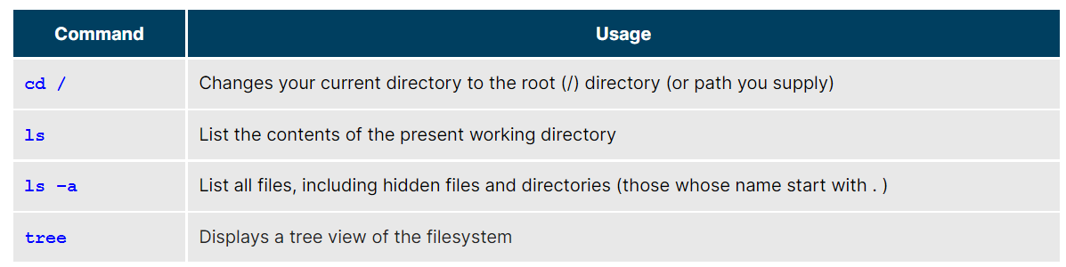

* The **ln** utility is used to create hard links and (with the **-s** option) soft links, also known as symbolic links or symlinks. These two kinds of links are very useful in UNIX-based operating systems.
* Suppose that **file1** already exists. A hard link, called **file2**, is created with the command:
* **$ ln file1 file2**
* Note that two files now appear to exist. However, a closer inspection of the file listing shows that this is not quite true.
* **$ ls -li file1 file2**
* The **-i** option to **ls** prints out in the first column the inode number, which is a unique quantity for each file object. This field is the same for both of these files; what is really going on here is that it is only one file, but it has more than one nameassociated with it, as is indicated by the **2** that appears in the **ls** output. Thus, there was already another object linked to **file1** before the command was executed.

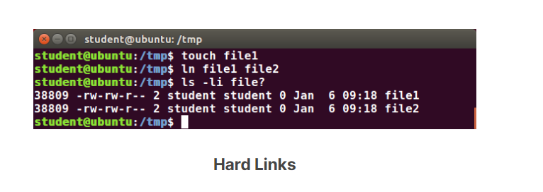

# **Soft (Symbolic) Links**

Soft (or Symbolic) links are created with the **-s** option, as in:

**$ ln -s file1 file3**  
**$ ls -li file1 file3**

Notice **file3** no longer appears to be a regular file, and it clearly points to **file1** and has a different inode number.

Symbolic links take no extra space on the filesystem (unless their names are very long). They are extremely convenient, as they can easily be modified to point to different places. An easy way to create a shortcut from your **home** directory to long pathnames is to create a symbolic link.

Unlike hard links, soft links can point to objects even on different filesystems, partitions, and/or disks and other media, which may or may not be currently available or even exist. In the case where the link does not point to a currently available or existing object, you obtain a dangling link.

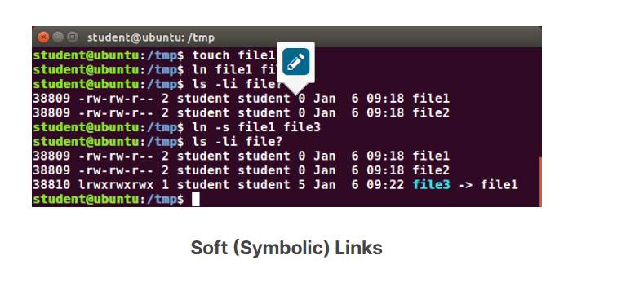

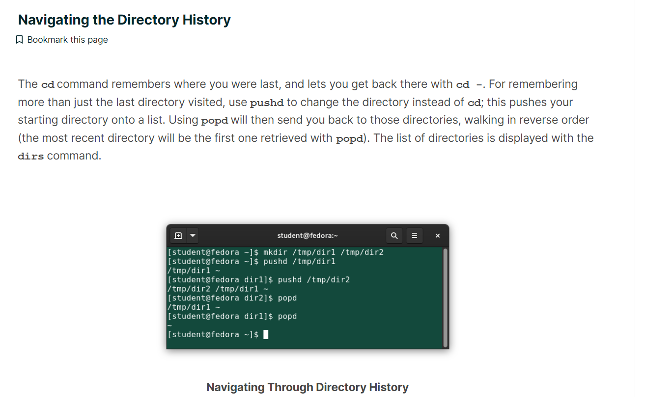

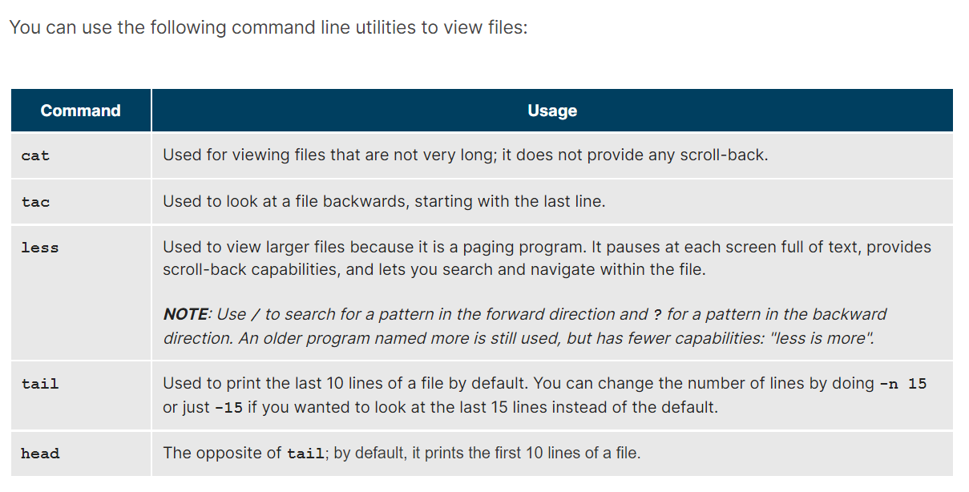  
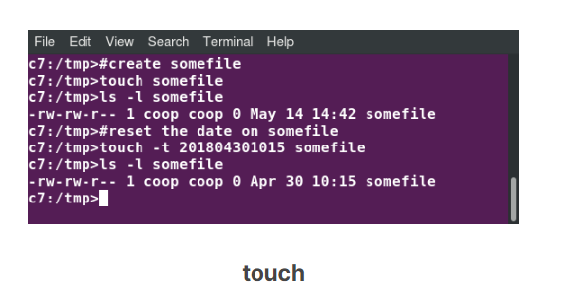

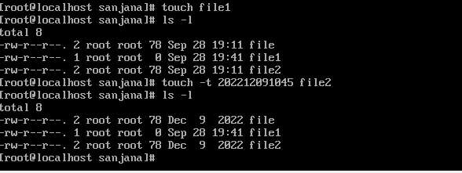

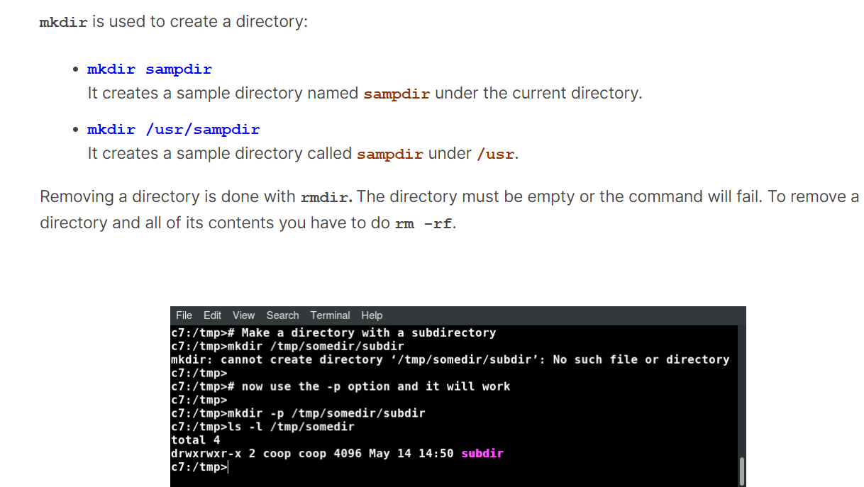

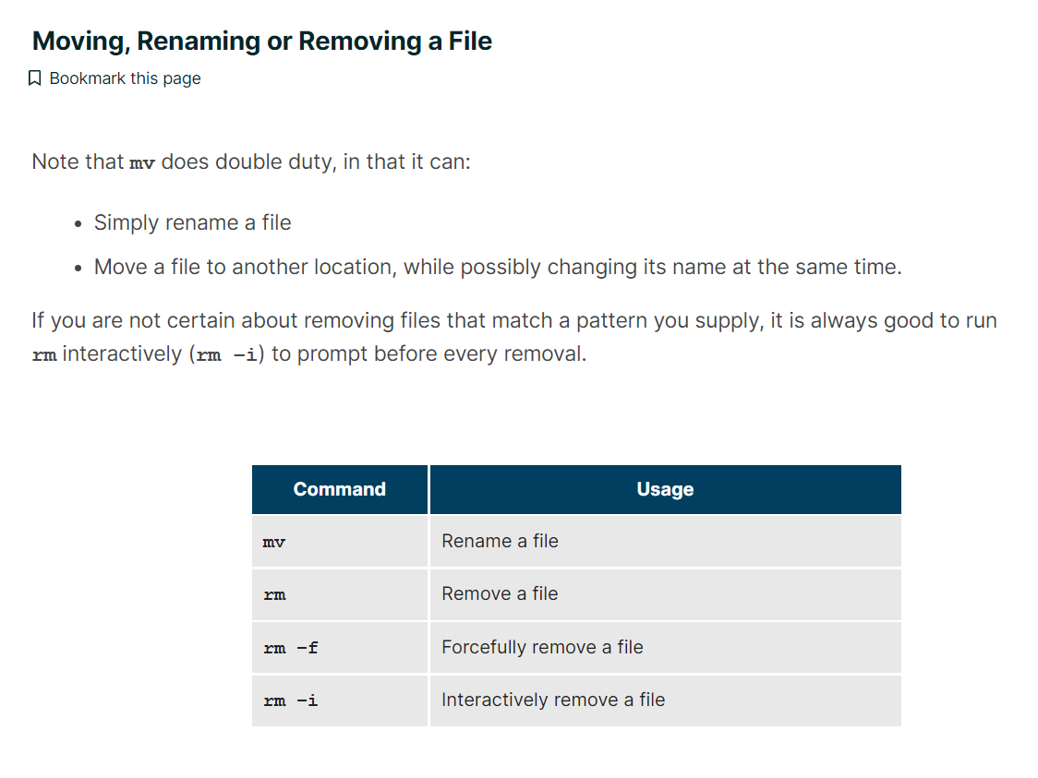

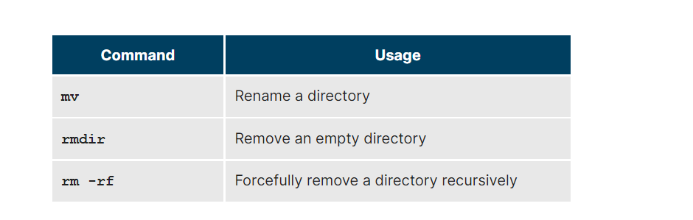

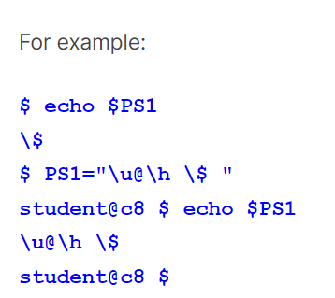

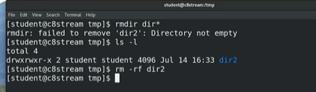

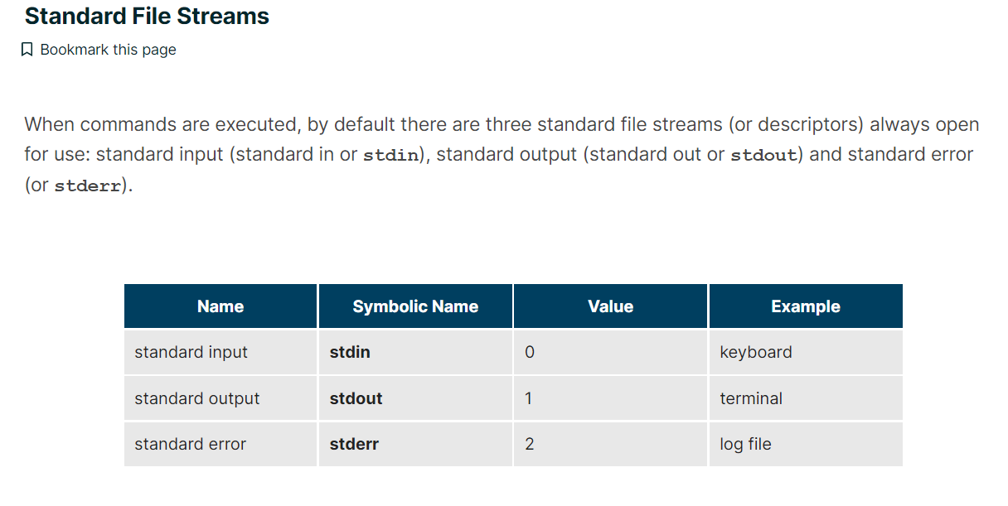

For example, if we have a program called **do_something** that reads from **stdin** and writes to **stdout** and **stderr**, we can change its input source by using the less-than sign (**<**) followed by the name of the file to be consumed for input data:

**$ do_something < input-file**

If you want to send the output to a file, use the greater-than sign (**>**) as in:  
  
$ do_something > output-file

The UNIX/Linux philosophy is to have many simple and short programs (or commands) cooperate together to produce quite complex results, rather than have one complex program with many possible options and modes of operation. In order to accomplish this, extensive use of pipes is made. You can pipe the output of one command or program into another as its input.

In order to do this, we use the vertical-bar, pipe symbol (**|**), between commands as in:  
   
$ command1 | command2 | command3

To get a shorter (and possibly more relevant) list, we can use the **grep** program as a filter. **grep** will print only the lines that contain one or more specified strings, as in:

**$ locate zip | grep bin**

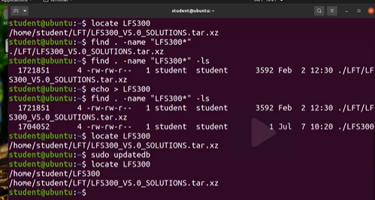

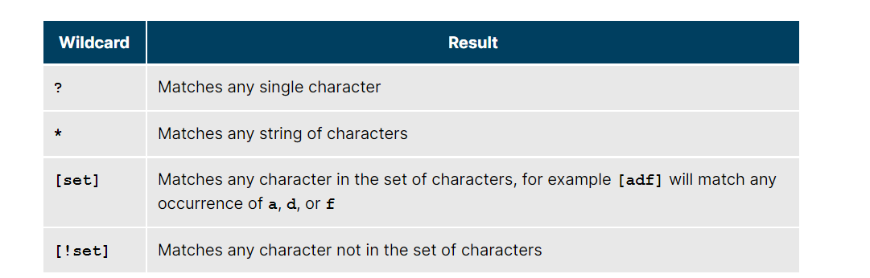

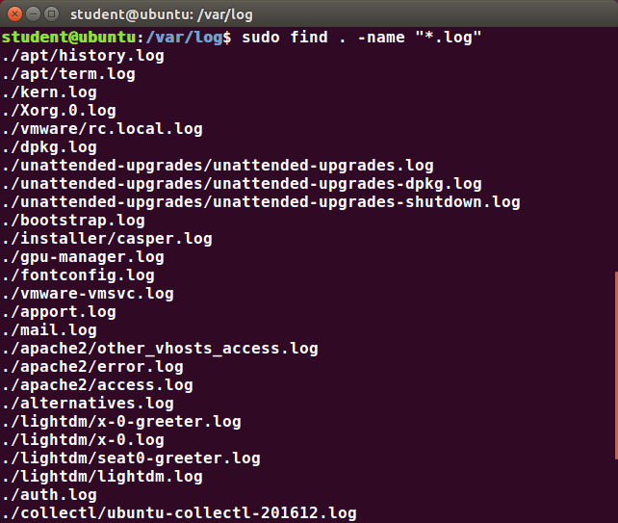

Searching for files and directories named **gcc**:  
  
$ find /usr -name gcc

Searching only for directories named **gcc**:  
  
$ find /usr -type d -name gcc

Searching only for regular files named **gcc**:  
  
$ find /usr -type f -name gcc

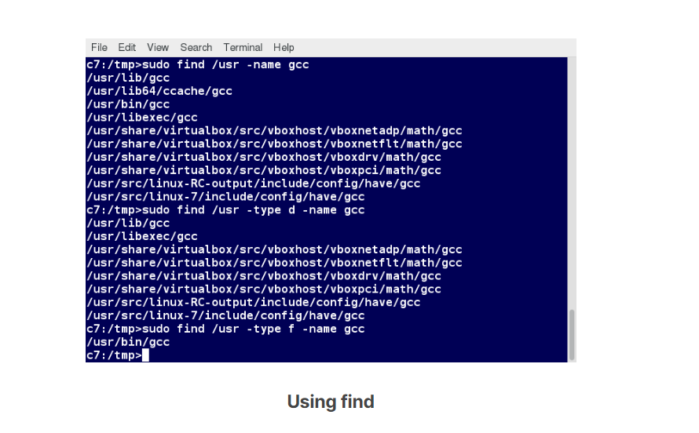

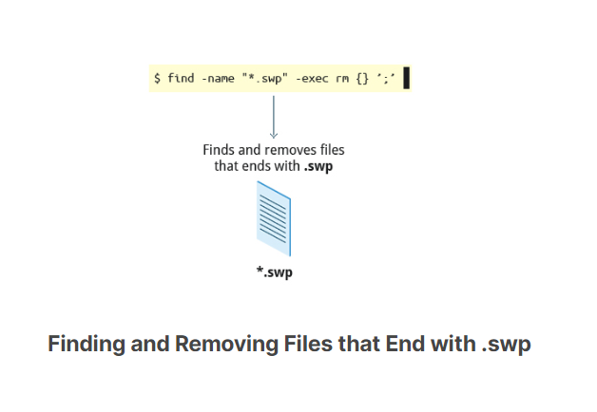

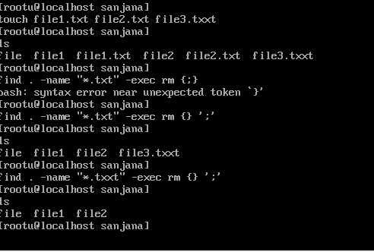

# **Finding Files Based on Time and Size**

It is sometimes the case that you wish to find files according to attributes, such as when they were created, last used, etc., or based on their size. It is easy to perform such searches.

To find files based on time:  
  
$ find / -ctime 3

Here, **-ctime** is when the inode metadata (i.e. file ownership, permissions, etc.) last changed; it is often, but not necessarily, when the file was first created. You can also search for accessed/last read (**-atime**) or modified/last written (**-mtime**) times. The number is the number of days and can be expressed as either a number (**n**) that means exactly that value, **+n**, which means greater than that number, or **-n**, which means less than that number. There are similar options for times in minutes (as in **-cmin**, **-amin**, and **-mmin**).

To find files based on sizes:

**$ find / -size 0**

Note the size here is in 512-byte blocks, by default; you can also specify bytes (c), kilobytes (k), megabytes (M), gigabytes (G), etc. As with the time numbers above, file sizes can also be exact numbers (**n**), **+n** or **-n**. For details, consult the manpage for find.

For example, to find files greater than 10 MB in size and running a command on those files:  
  
$ find / -size +10M -exec command {} ’;’

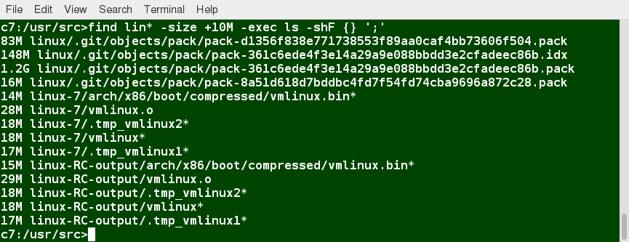

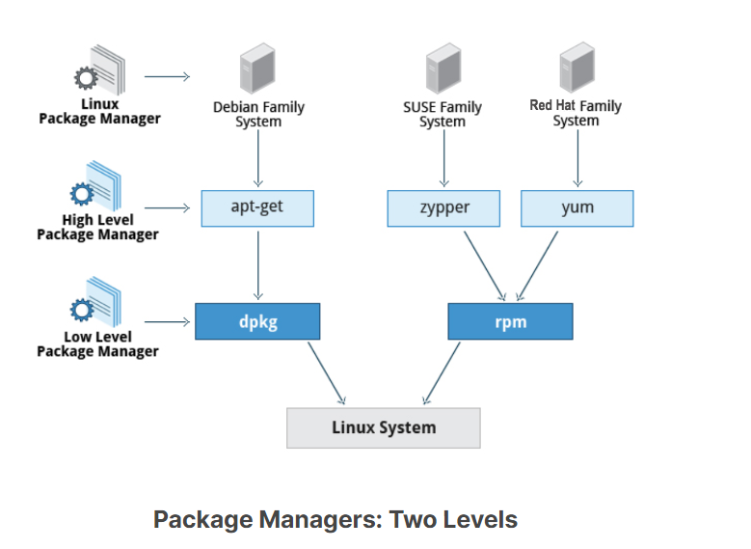

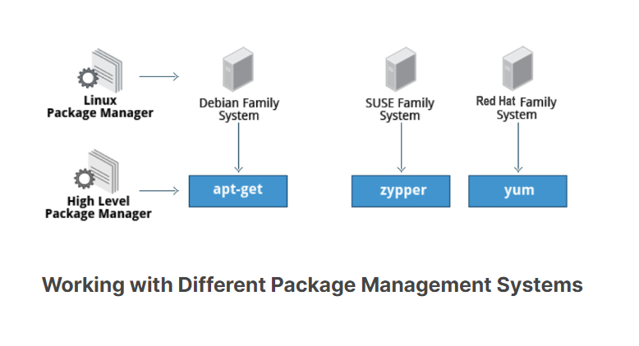

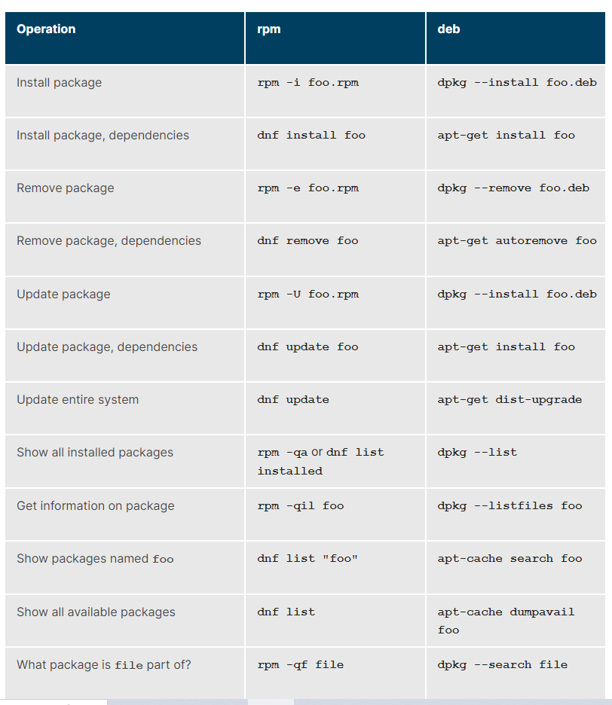

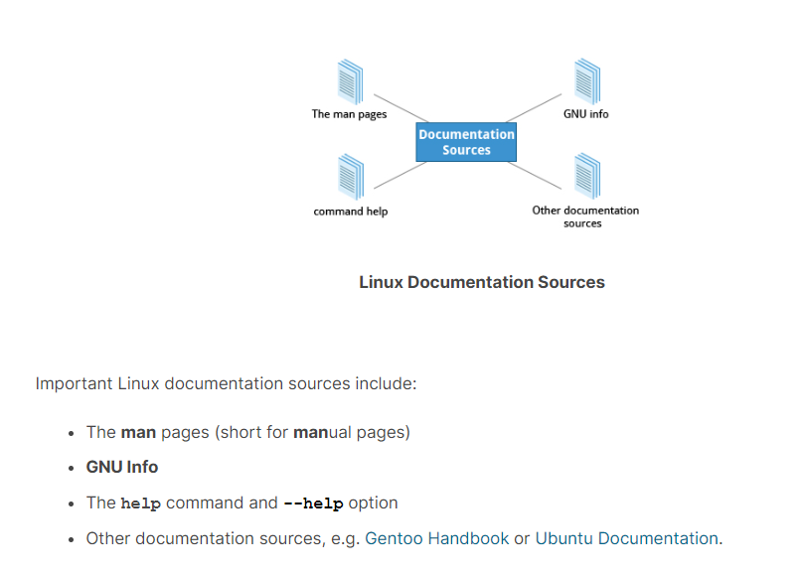

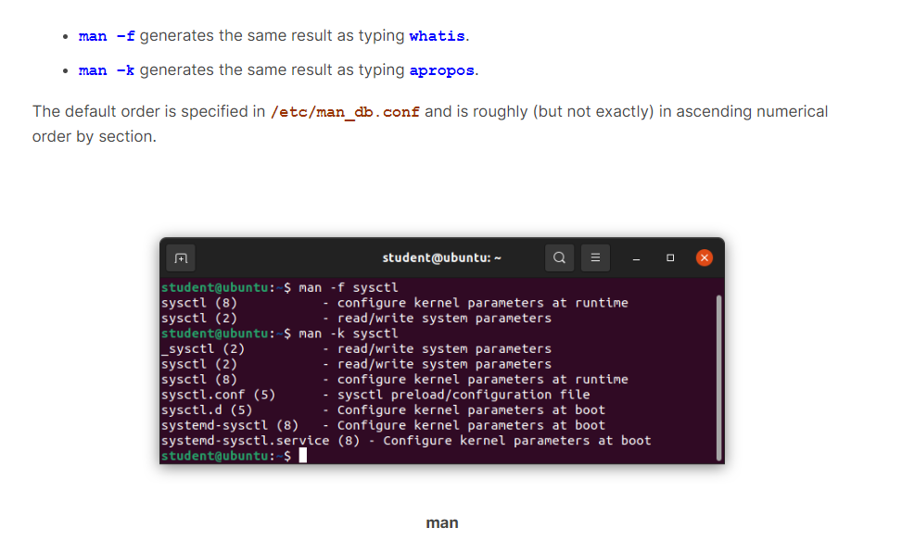

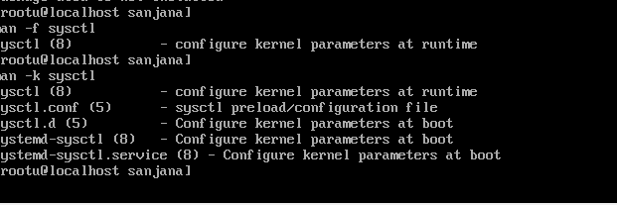

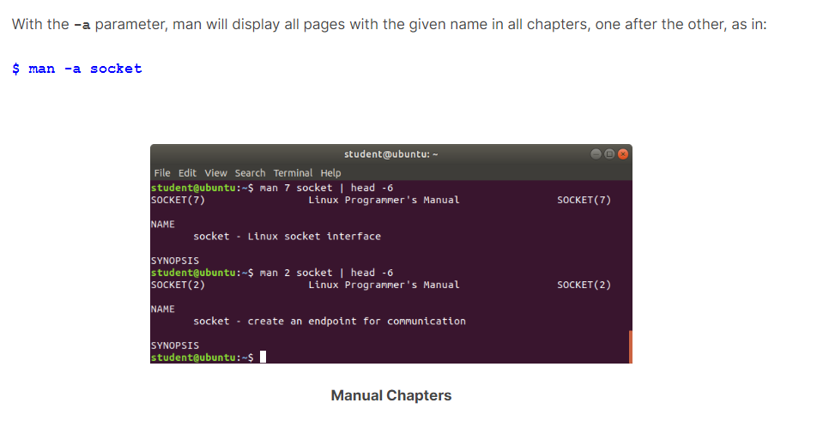

* The man pages are divided into chapters numbered 1 through 9. In some cases, a letter is appended to the chapter number to identify a specific topic. For example, many pages describing part of the X Window API are in chapter **3X**.
* The topic which you view in an info page is called a **node**. The table lists the basic keystrokes for moving between nodes.

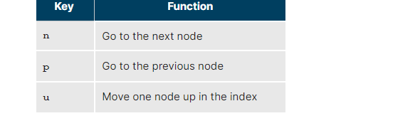

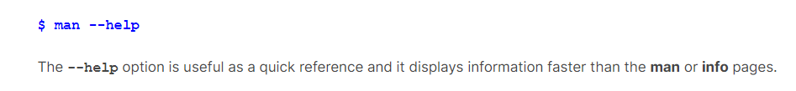

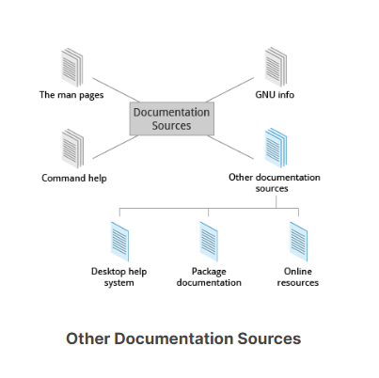

If you do not want to spend time hunting for the right icon or menu item to launch the help application, you can also start the graphical help system from a terminal window or command prompt by using one of the following utility programs:

* + - GNOME: **gnome-help** or **yelp**
    - KDE: **khelpcenter**

[Official Ubuntu Documentation](https://help.ubuntu.com/)

[Documentation - CentOS Wiki](https://wiki.centos.org/Documentation)

[openSUSE Documentation](https://doc.opensuse.org/)

[Documentation – Gentoo Linux](https://www.gentoo.org/support/documentation/)

[Fedora Documentation :: Fedora Docs (fedoraproject.org)](https://docs.fedoraproject.org/en-US/docs/)

You have completed Chapter 8. Let’s summarize the key concepts covered:

* + - The main sources of Linux documentation are the man pages, GNU info, the **help** options and command, and a rich variety of online documentation sources.
    - The **man** utility searches, formats, and displays man pages.
    - The man pages provide in-depth documentation about programs and other topics about the system, including configuration files, system calls, library routines, and the kernel.
    - The GNU Info System was created by the GNU project as its standard documentation. It is robust and is accessible via command line, web, and graphical tools using **info**.
    - Short descriptions for commands are usually displayed with the **-h** or **--help** argument.
    - You can type **help** at the command line to display a synopsis of built-in commands.
    - There are many other help resources both on your system and on the Internet.

You have completed Chapter 8. Let’s summarize the key concepts covered:

* + - The main sources of Linux documentation are the man pages, GNU info, the **help** options and command, and a rich variety of online documentation sources.
    - The **man** utility searches, formats, and displays man pages.
    - The man pages provide in-depth documentation about programs and other topics about the system, including configuration files, system calls, library routines, and the kernel.
    - The GNU Info System was created by the GNU project as its standard documentation. It is robust and is accessible via command line, web, and graphical tools using **info**.
    - Short descriptions for commands are usually displayed with the **-h** or **--help** argument.
    - You can type **help** at the command line to display a synopsis of built-in commands.
    - There are many other help resources both on your system and on the Internet.

**Process:**  
A **process** is simply an instance of one or more related tasks (threads) executing on your computer. It is not the same as a **program** or a **command**. A single command may actually start several processes simultaneously. Some processes are independent of each other and others are related. A failure of one process may or may not affect the others running on the system.

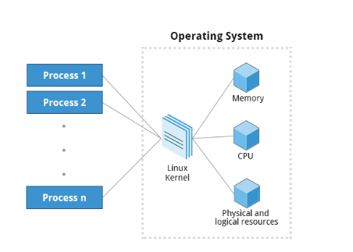

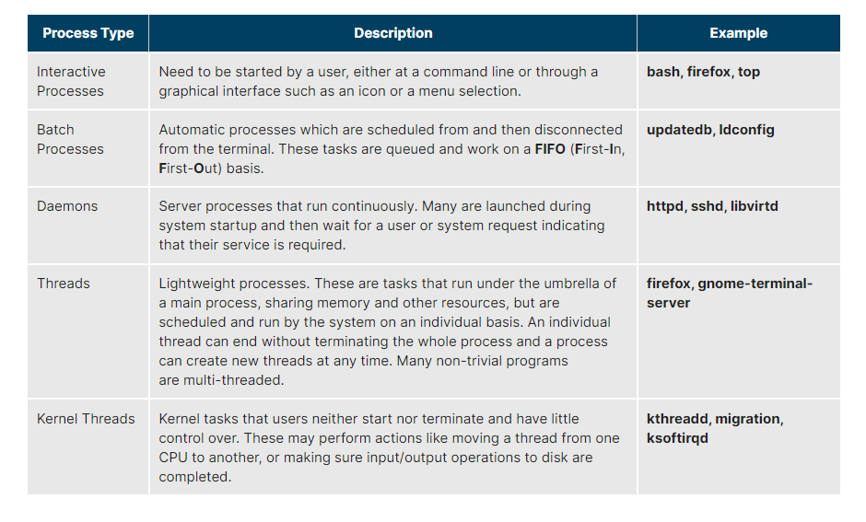

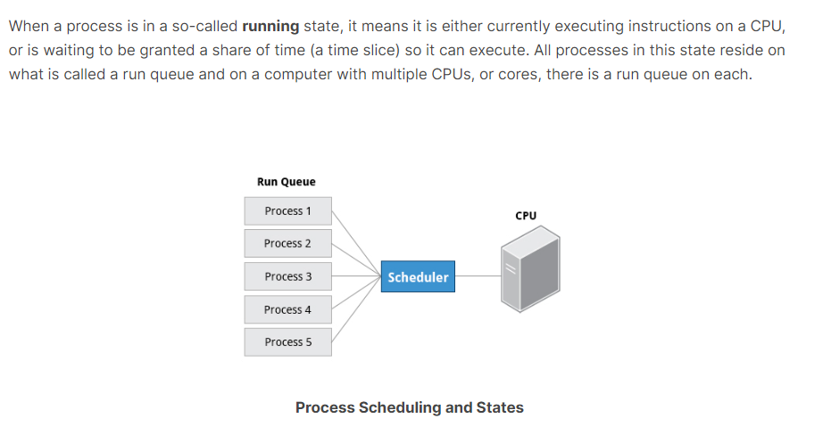

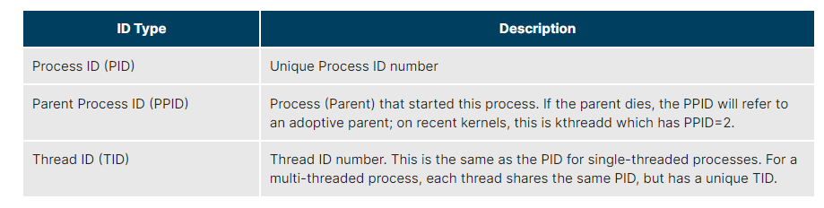

At some point, one of your applications may stop working properly. How do you eliminate it?

To terminate a process, you can type **kill -SIGKILL <pid>** or **kill -9 <pid>**.

Note, however, you can only kill your own processes; those belonging to another user are off limits, unless you are root.

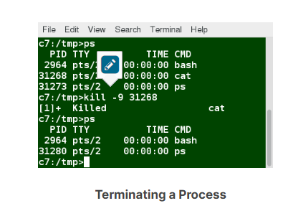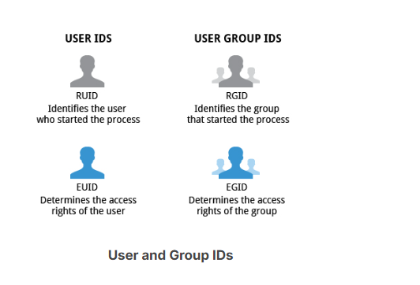

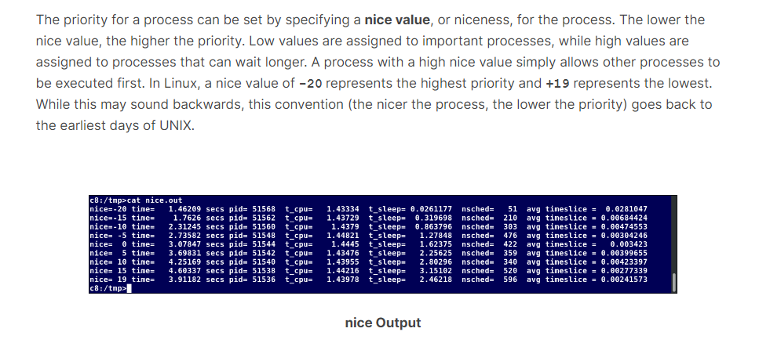

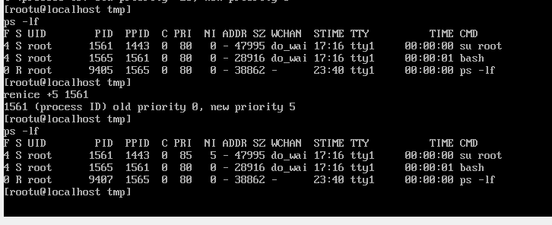

The **load average** is the average of the load number for a givenperiod of time. It takes into account processes that are:

* + - Actively running on a CPU.
    - Considered runnable, but waiting for a CPU to become available.
    - Sleeping: i.e. waiting for some kind of resource (typically, I/O) to become available.

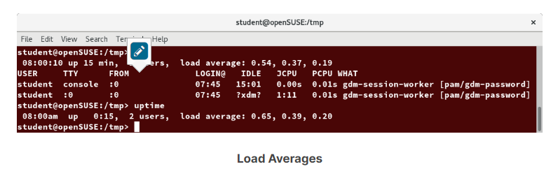

The load average is displayed using three numbers (**0.45**, **0.17**, and **0.12**) in the below screenshot. Assuming our system is a single-CPU system, the three load average numbers are interpreted as follows:

* + - **0.45**: For the last minute the system has been 45% utilized on average.
    - **0.17**: For the last 5 minutes utilization has been 17%.
    - **0.12**: For the last 15 minutes utilization has been 12%.
    - In such cases, you can run the job in the background and free the shell for other tasks. The background job will be executed at lower priority, which, in turn, will allow smooth execution of the interactive tasks, and you can type other commands in the terminal window while the background job is running. By default, all jobs are executed in the foreground. You can put a job in the background by suffixing **&** to the command, for example: **updatedb &**.
    - You can either use **CTRL-Z** to suspend a foreground job or **CTRL-C** to terminate a foreground job and can always use the **bg** and **fg** commands to run a process in the background and foreground, respectively.

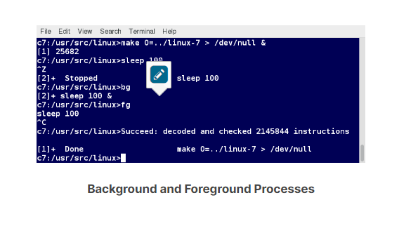

* The **jobs** utility displays all jobs running in background. The display shows the job ID, state, and command name, as shown here.
* **jobs -l** provides the same information as **jobs**, and adds the PID of the background jobs.
* The background jobs are connected to the terminal window, so, if you log off, the **jobs** utility will not show the ones started from that window.
* **ps** has another style of option specification, which stems from the BSD variety of UNIX, where options are specified without preceding dashes. For example, the command **ps aux** displays all processes of all users.
* The command **ps axo** allows you to specify which attributes you want to view.

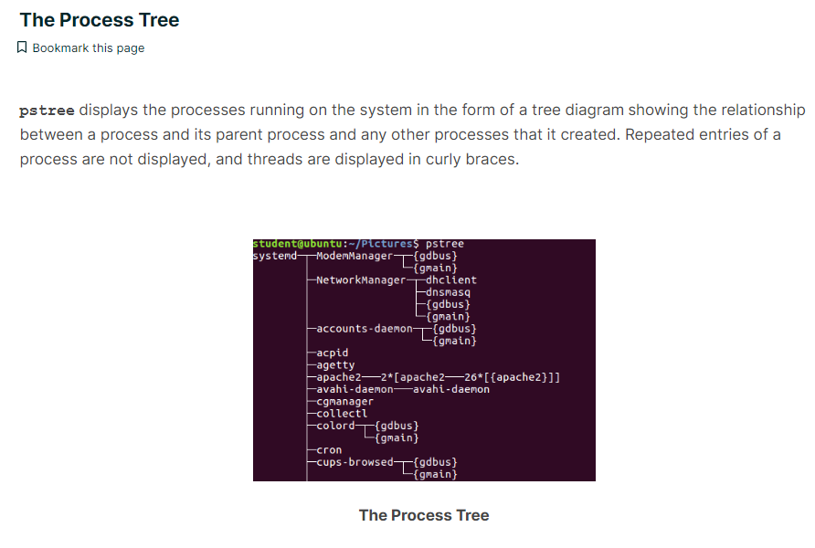

**Top :**

While a static view of what the system is doing is useful, monitoring the system performance live over time is also valuable. One option would be to run **ps** at regular intervals, say, every few seconds. A better alternative is to use **top** to get constant real-time updates (every two seconds by default), until you exit by typing **q.top** clearly highlights which processes are consuming the most CPU cycles and memory (using appropriate commands from within **top**).

The first line of the **top** output displays a quick summary of what is happening in the system, including:

* + - How long the system has been up
    - How many users are logged on
    - What is the load average

The load average determines how busy the system is. A load average of 1.00 per CPU indicates a fully subscribed, but not overloaded, system. If the load average goes above this value, it indicates that processes are competing for CPU time. If the load average is very high, it might indicate that the system is having a problem, such as a runaway process (a process in a non-responding state).

The second line of the **top** output displays the total number of processes, the number of running, sleeping, stopped, and zombie processes. Comparing the number of running processes with the load average helps determine if the system has reached its capacity or perhaps a particular user is running too many processes. The stopped processes should be examined to see if everything is running correctly.

The third line of the **top** output indicates how the CPU time is being divided between the users (**us**) and the kernel (**sy**) by displaying the percentage of CPU time used for each.

The fourth and fifth lines of the **top** output indicate memory usage, which is divided in two categories:

* + - Physical memory (RAM) – displayed on line 4.
    - Swap space – displayed on line 5.
    - Both categories display total memory, used memory, and free space.
* Each line in the process list of the **top** output displays information about a process. By default, processes are ordered by highest CPU usage. The following information about each process is displayed:
  + - Process Identification Number (**PID**)
    - Process owner (**USER)**
    - Priority (**PR**) and nice values (**NI**)
    - Virtual (**VIRT**), physical (**RES**), and shared memory (**SHR**)
    - Status (**S**)
    - Percentage of CPU (**%CPU**) and memory (**%MEM**) used
    - Execution time (**TIME+**)
    - Command (**COMMAND**).

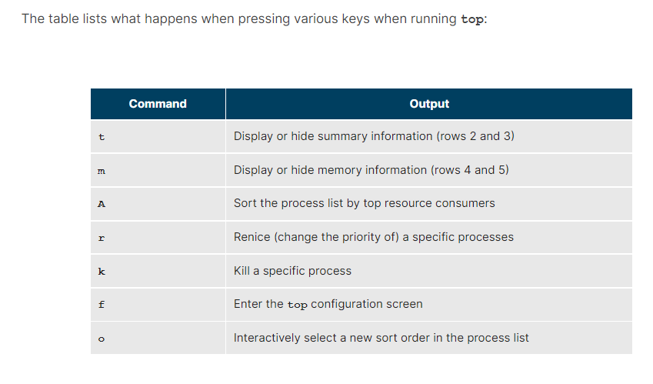

# **Scheduling Future Processes Using at:**

Suppose you need to perform a task on a specific day sometime in the future. However, you know you will be away from the machine on that day. How will you perform the task? You can use the **at** utility program to execute any non-interactive command at a specified time, as illustrated in the screenshot below:

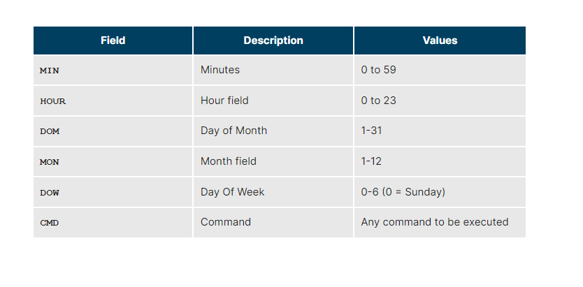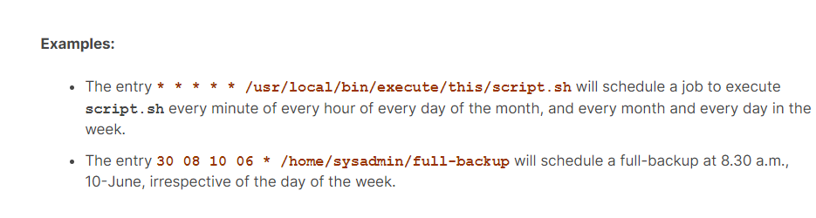

**sleep** suspends execution for at least the specified period of time, which can be given as the number of seconds (the default), minutes, hours, or days. After that time has passed (or an interrupting signal has been received), execution will resume.

The syntax is:  
  
sleep NUMBER[SUFFIX]...  
  
where **SUFFIX** may be:

* + - **s** for seconds (the default)
    - **m** for minutes
    - **h** for hours
    - **d** for days.

**sleep** and **at** are quite different; **sleep** delays execution for a specific period, while **at** starts execution at a later time.

You have completed Chapter 9. Let’s summarize the key concepts covered:

* + - Processes are used to perform various tasks on the system.
    - Processes can be single-threaded or multi-threaded.
    - Processes can be of different types, such as interactive and non-interactive.
    - Every process has a unique identifier (PID) to enable the operating system to keep track of it.
    - The nice value, or niceness, can be used to set priority.
    - **ps** provides information about the currently running processes.
    - You can use **top** to get constant real-time updates about overall system performance, as well as information about the processes running on the system.
    - Load average indicates the amount of utilization the system is under at particular times.
    - Linux supports background and foreground processing for a job.
    - **at** executes any non-interactive command at a specified time.
    - **cron** is used to schedule tasks that need to be performed at regular intervals.

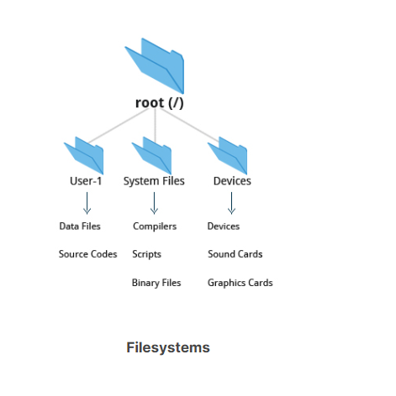

Linux supports a number of native filesystem types, expressly created by Linux developers, such as:

* + - ext3
    - ext4
    - squashfs
    - btrfs.

It also offers implementations of filesystems used on other alien operating systems, such as those from:

* + - Windows (ntfs, vfat)
    - SGI (xfs)
    - IBM (jfs)
    - MacOS (hfs, hfs+).

Many older, legacy filesystems, such as FAT, are also supported.

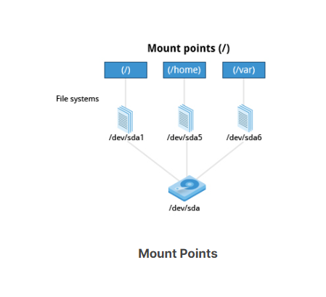

The **mount** command is used to attach a filesystem (which can be local to the computer or on a network) somewhere within the filesystem tree. The basic arguments are the **device node** and mount point. For example,

**$ sudo mount /dev/sda5 /home**

will attach the filesystem contained in the disk partition associated with the **/dev/sda5** device node, into the filesystem tree at the **/home** mount point. There are other ways to specify the partition other than the device node, such as using the disk label or UUID.

To unmount the partition, the command would be:

**$ sudo umount /home**

Note the command is **umount**, not unmount! Only a root user (logged in as root, or using **sudo**) has the privilege to run these commands, unless the system has been otherwise configured.

If you want it to be automatically available every time the system starts up, you need to edit **/etc/fstab** accordingly (the name is short for filesystem table). Looking at this file will show you the configuration of all pre-configured filesystems. **man fstab** will display how this file is used and how to configure it.

Executing **mount** without any arguments will show all presently mounted filesystems.

The command **df -Th** (disk-free) will display information about mounted filesystems, including the filesystem type, and usage statistics about currently used and available space.

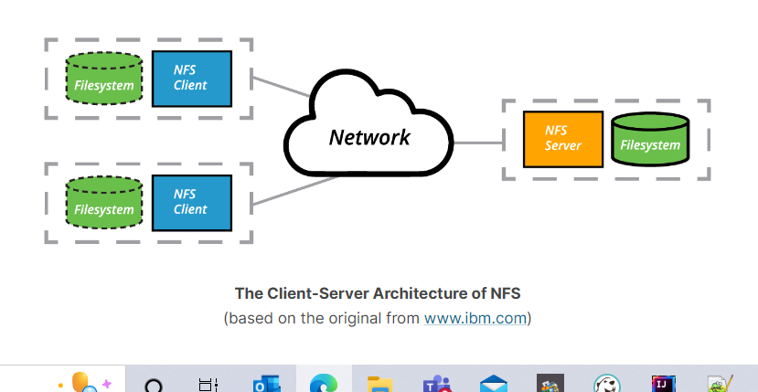

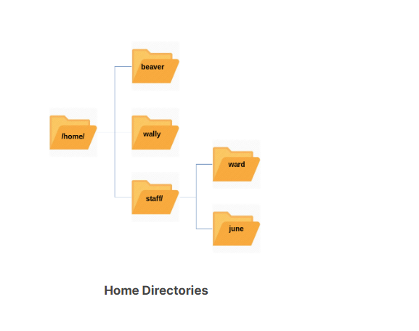

**File System :**

* The **/bin** directory contains executable binaries, essential commands used to boot the system or in single-user mode, and essential commands required by all system users, such as **cat**, **cp**, **ls**, **mv**, **ps**, and **rm**.
* Likewise, the **/sbin** directory is intended for essential binaries related to system administration, such as **fsck** and **ip**.To view a list of these programs, type:
* Certain filesystems, like the one mounted at **/proc**, are called **pseudo-filesystems** because they have no permanent presence anywhere on the disk.
* The **/proc** filesystem contains virtual files (files that exist only in memory) that permit viewing constantly changing kernel data. **/proc** contains files and directories that mimic kernel structures and configuration information. It does not contain real files, but runtime system information, e.g. system memory, devices mounted, hardware configuration, etc. Some important entries in **/proc** are:
* **/proc/cpuinfo**  
  **/proc/interrupts**  
  **/proc/meminfo**  
  **/proc/mounts**  
  **/proc/partitions**  
  **/proc/version**
* The **/dev** directory contains **device nodes**, a type of pseudo-file used by most hardware and software devices, except for network devices. This directory is:
  + - Empty on the disk partition when it is not mounted
    - Contains entries which are created by the **udev** system, which creates and manages device nodes on Linux, creating them dynamically when devices are found. The **/dev** directory contains items such as:
      * + **/dev/sda1** (first partition on the first hard disk)
        + **/dev/lp1** (second printer)
        + **/dev/random** (a source of random numbers).
* The **/var** directory contains files that are expected to change in size and content as the system is running (var stands for variable), such as the entries in the following directories:
  + - System log files: **/var/log**
    - Packages and database files: **/var/lib**
    - Print queues: **/var/spool**
    - Temporary files: **/var/tmp**.
* The **/etc** directory is the home for system configuration files. It contains no binary programs, although there are some executable scripts. For example, **/etc/resolv.conf** tells the system where to go on the network to obtain host name to IP address mappings (DNS). Files like **passwd**, **shadow** and **group** for managing user accounts are found in the **/etc** directory. While some distributions have historically had their own extensive infrastructure under **/etc** (for example, Red Hat and SUSE have used **/etc/sysconfig**), with the advent of **systemd** there is much more uniformity among distributions today.
* The **/boot** directory contains the few essential files needed to boot the system. For every alternative kernel installed on the system there are four files:
  + - **vmlinuz**  
      **The compressed Linux kernel, required for booting.**
    - **initramfs**  
      **The initial ram filesystem, required for booting, sometimes called initrd, not initramfs.**
    - **config**  
      **The kernel configuration file, only used for debugging and bookkeeping.**
    - **System.map**  
      **Kernel symbol table, only used for debugging.**
* **/lib** contains libraries (common code shared by applications and needed for them to run) for the essential programs in **/bin** and **/sbin**. These library filenames either start with **ld** or **lib**. For example, **/lib/libncurses.so.5.9**.
* Most of these are what is known as dynamically loaded libraries (also known as shared libraries or Shared Objects (SO)). On some Linux distributions there exists a **/lib64** directory containing 64-bit libraries, while **/lib** contains 32-bit versions.
* The **/mnt** directory has been used since the early days of UNIX for temporarily mounting filesystems. These can be those on removable media, but more often might be network filesystems, which are not normally mounted. Or these can be temporary partitions, or so-called **loopback** filesystems, which are files which pretend to be partitions.
* The **/mnt** directory has been used since the early days of UNIX for temporarily mounting filesystems. These can be those on removable media, but more often might be network filesystems, which are not normally mounted. Or these can be temporary partitions, or so-called **loopback** filesystems, which are files which pretend to be partitions.

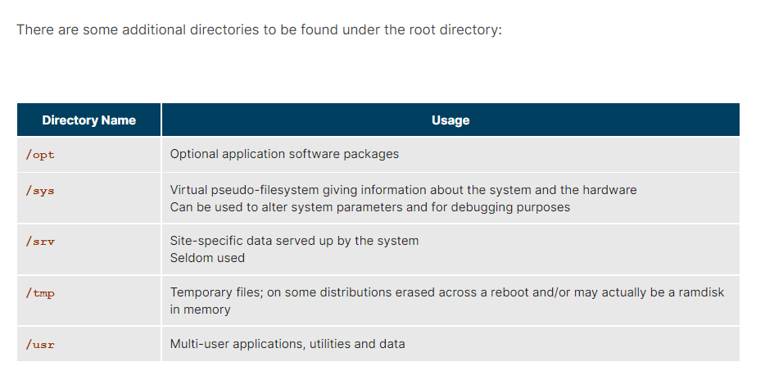

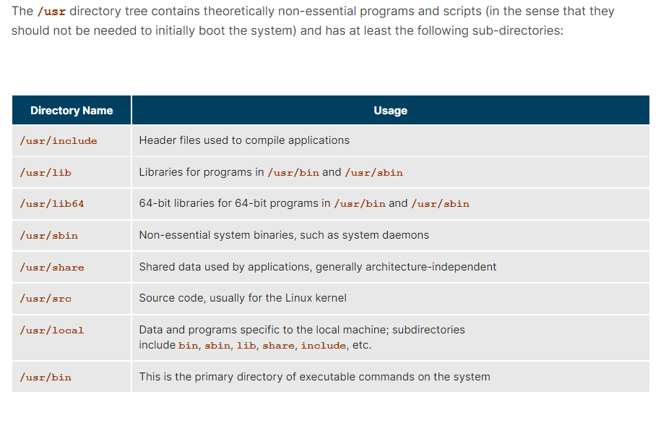

**diff** is used to compare files and directories. This often-used utility program has many useful options (see: **man diff**) including:

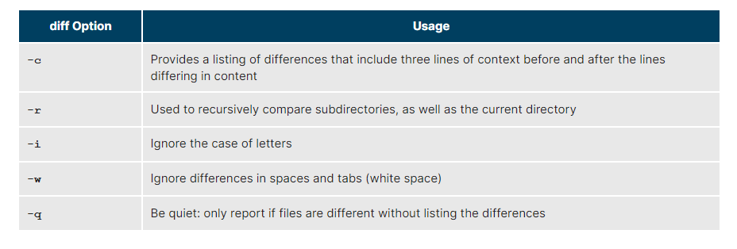

To compare two files, at the command prompt, type **diff [options] <filename1> <filename2>**. **diff** is meant to be used for text files; for binary files, one can use **cmp**.

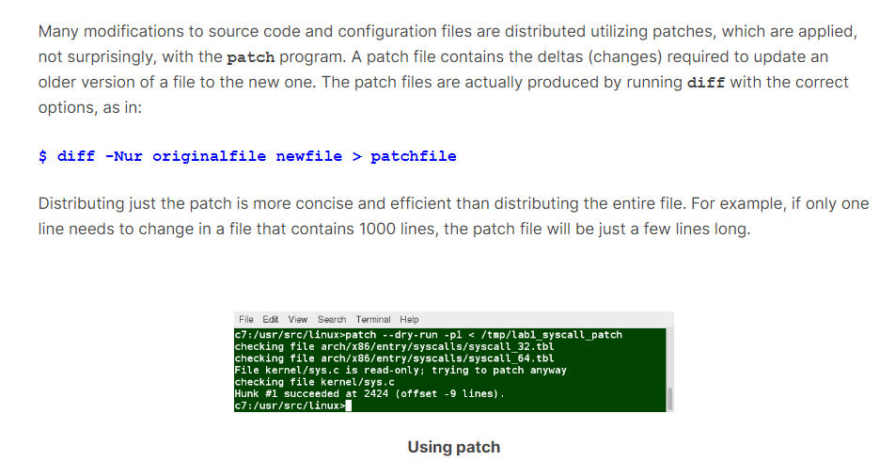

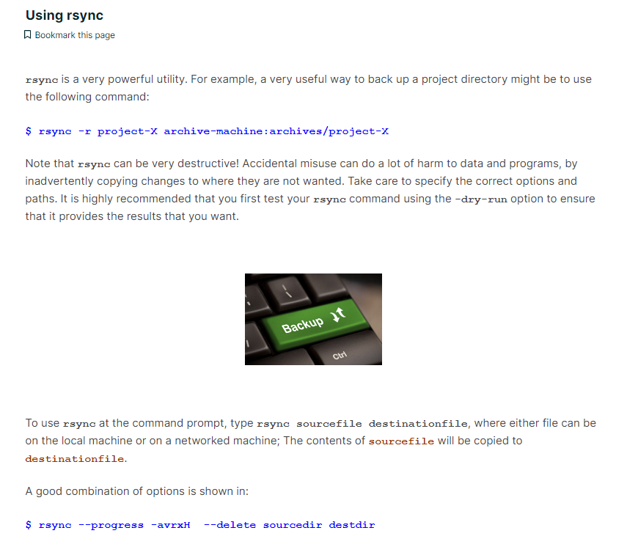

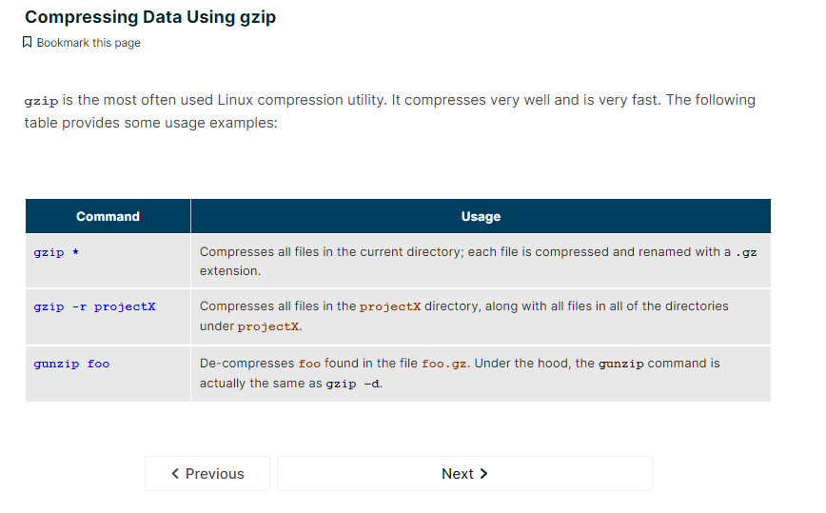

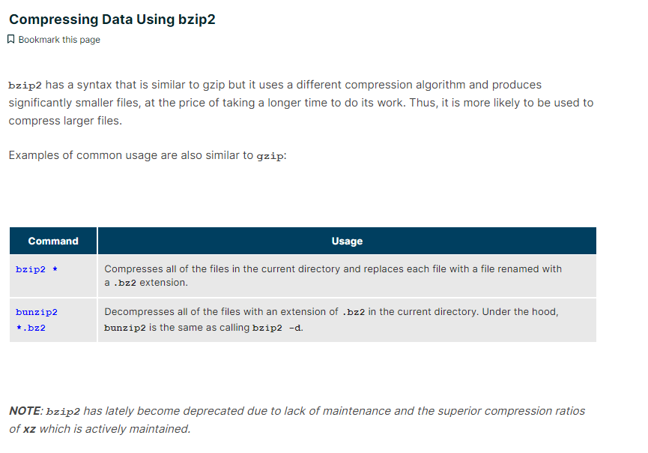

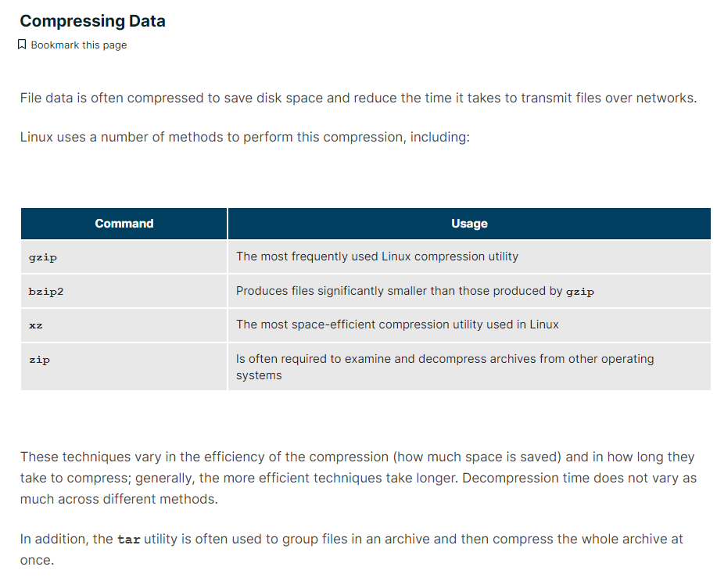

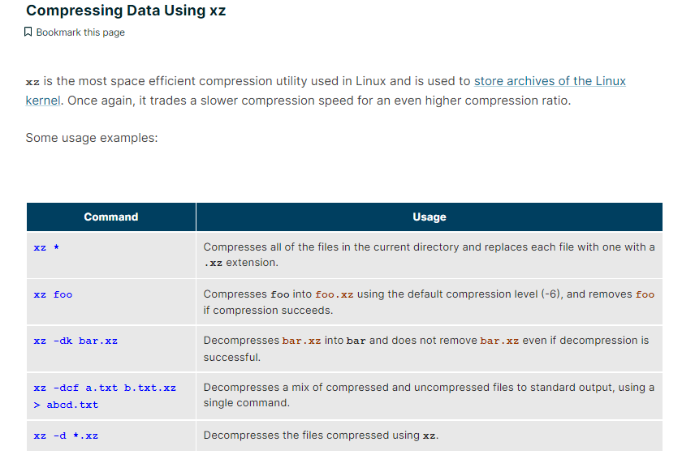

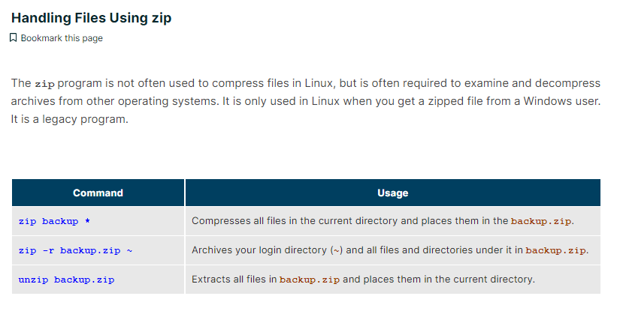

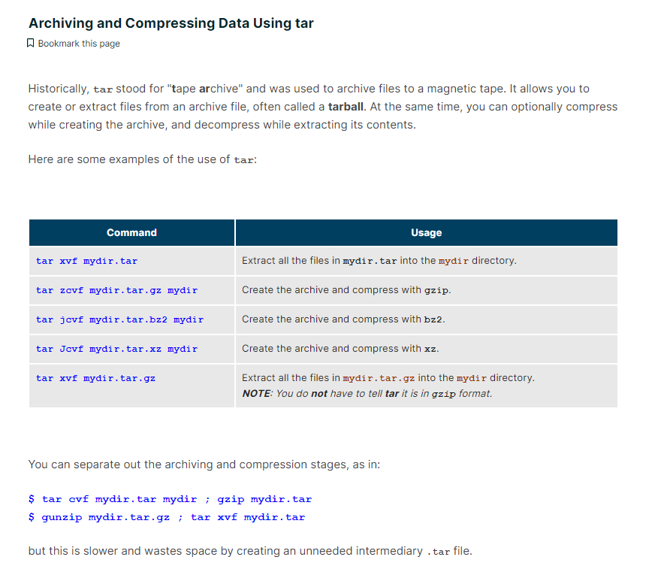

You have completed Chapter 10. Let’s summarize the key concepts covered:

* + - The filesystem tree starts at what is often called the root directory (or trunk, or **/**).
    - The Filesystem Hierarchy Standard (FHS) provides Linux developers and system administrators a standard directory structure for the filesystem.
    - Partitions help to segregate files according to usage, ownership, and type.
    - Filesystems can be mounted anywhere on the main filesystem tree at a mount point. Automatic filesystem mounting can be set up by editing **/etc/fstab**.
    - NFS (Network File System) is a useful method for sharing files and data through the network systems.
    - Filesystems like **/proc** are called pseudo filesystems because they exist only in memory.
    - **/root** (slash-root) is the home directory for the root user.
    - **/var** may be put in its own filesystem so that growth can be contained and not fatally affect the system.
    - **/boot** contains the basic files needed to boot the system.
    - **patch** is a very useful tool in Linux. Many modifications to source code and configuration files are distributed with patch files, as they contain the deltas or changes to go from an old version of a file to the new version of a file.
    - File extensions in Linux do not necessarily mean that a file is of a certain type.
    - **cp** is used to copy files on the local machine, while **rsync** can also be used to copy files from one machine to another, as well as synchronize contents.
    - **gzip**, **bzip2**, **xz** and **zip** are used to compress files.
    - **tar** allows you to create or extract files from an archive file, often called a tarball. You can optionally compress while creating the archive, and decompress while extracting its contents.
    - **dd** can be used to make large exact copies, even of entire disk partitions, efficiently.

By now, you have certainly realized Linux is packed with choices; when it comes to text editors, there are many choices, ranging from quite simple to very complex, including:

* + - **nano**
    - **gedit**
    - **vi**
    - **emacs**.

# **Creating Files Without Using an Editor**

Sometimes, you may want to create a short file and don't want to bother invoking a full text editor. In addition, doing so can be quite useful when used from within scripts, even when creating longer files. You will no doubt find yourself using this method when you start on the later chapters that cover shell scripting!

If you want to create a file without using an editor, there are two standard ways to create one from the command line and fill it with content.

The first is to use **echo** repeatedly:  
  
$ echo line one > myfile  
$ echo line two >> myfile  
$ echo line three >> myfile

Note that while a single greater-than sign (**>**) will send the output of a command to a file, two of them (**>>**) will append the new output to an existing file.

The second way is to use **cat** combined with redirection:

**$ cat << EOF > myfile**  
**> line one**  
**> line two**  
**> line three**  
**> EOF**  
**$**

Both techniques produce a file with the following lines in it:  
line one  
line two  
line three

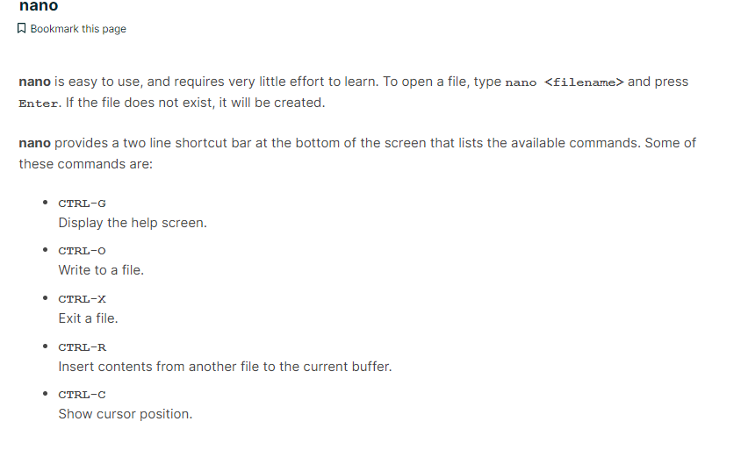

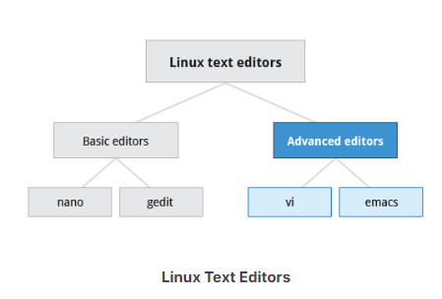

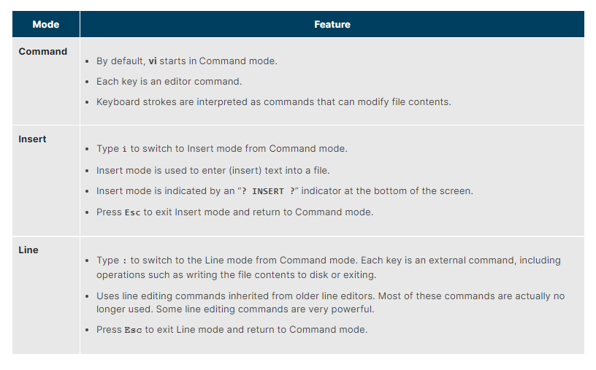

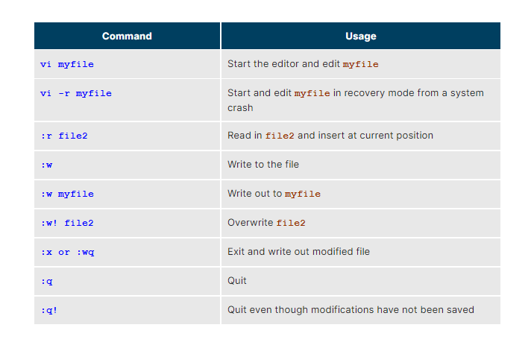

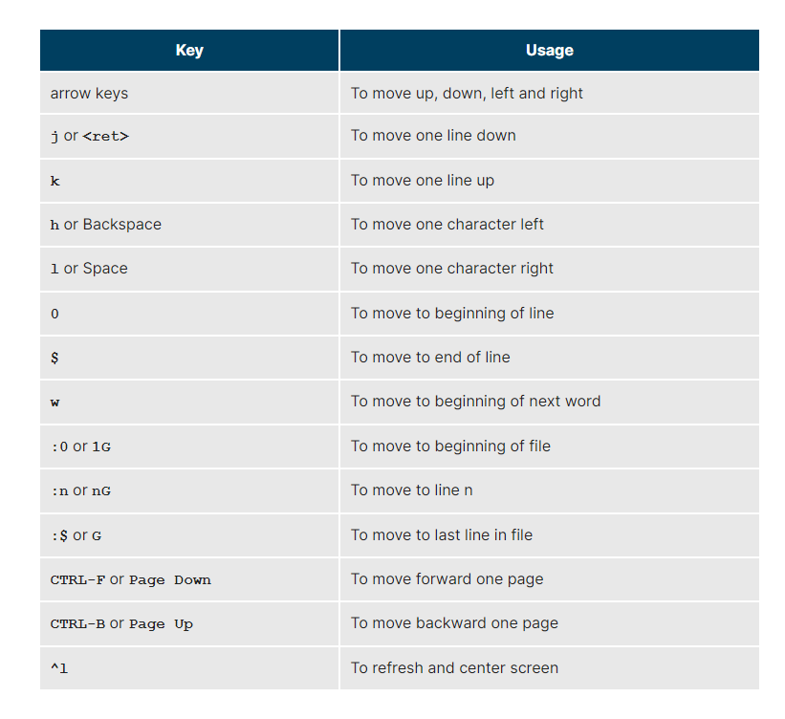

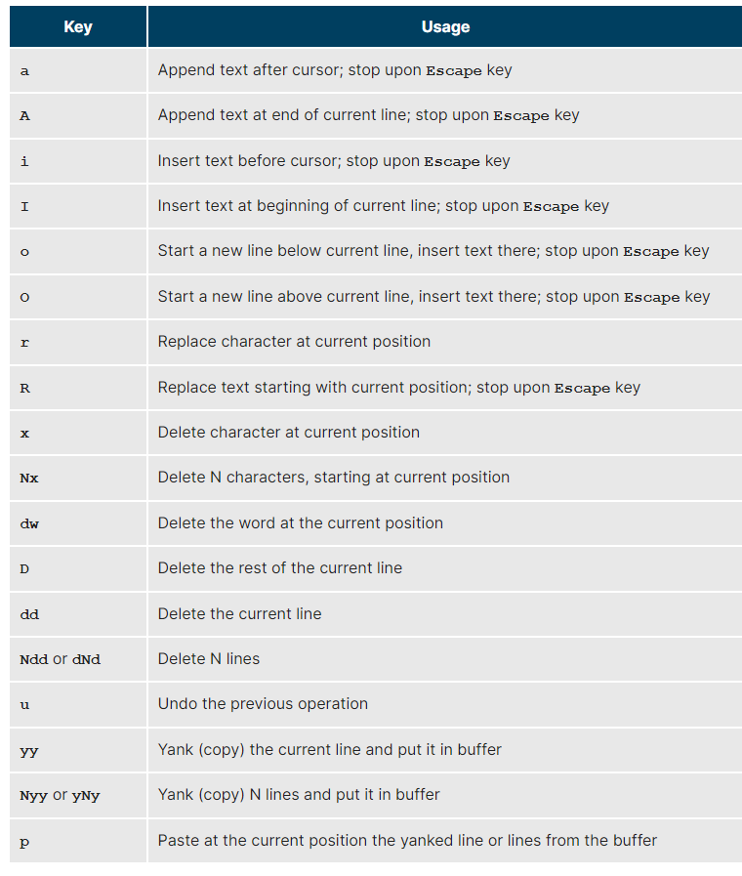

The **emacs** editor is a popular competitor for **vi**. Unlike **vi**, it does not work with modes. **emacs** is highly customizable and includes a large number of features. It was initially designed for use on a console, but was soon adapted to work with a GUI as well. **emacs** has many other capabilities other than simple text editing. For example, it can be used for email, debugging, etc.

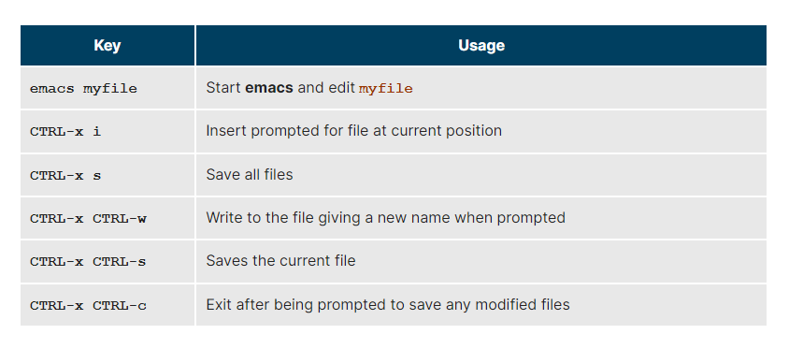

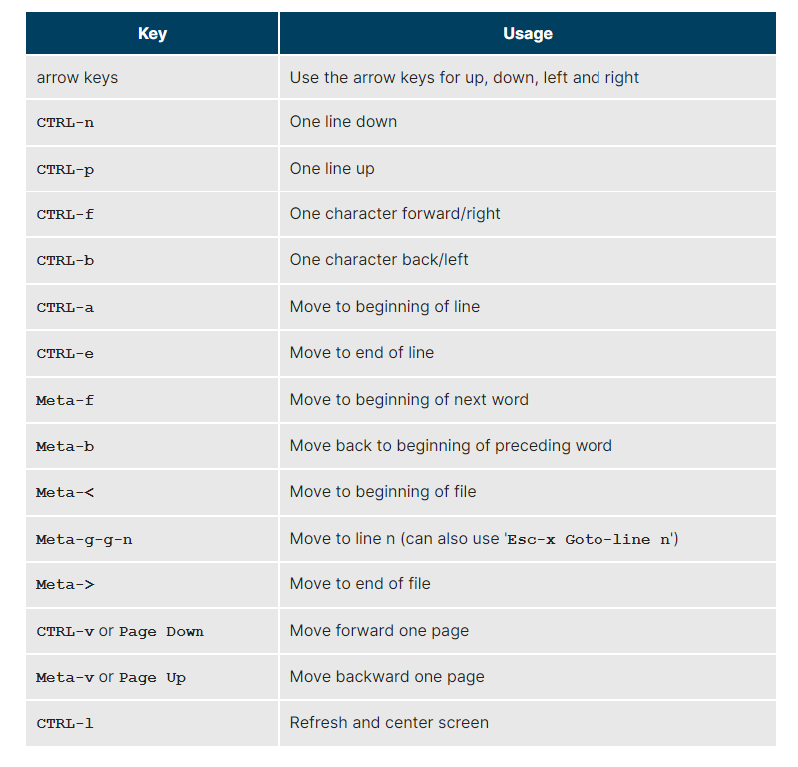

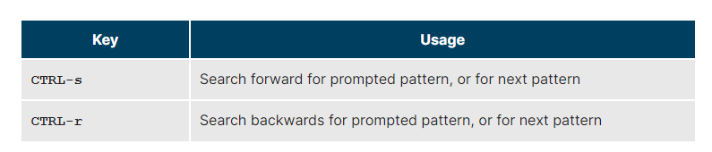

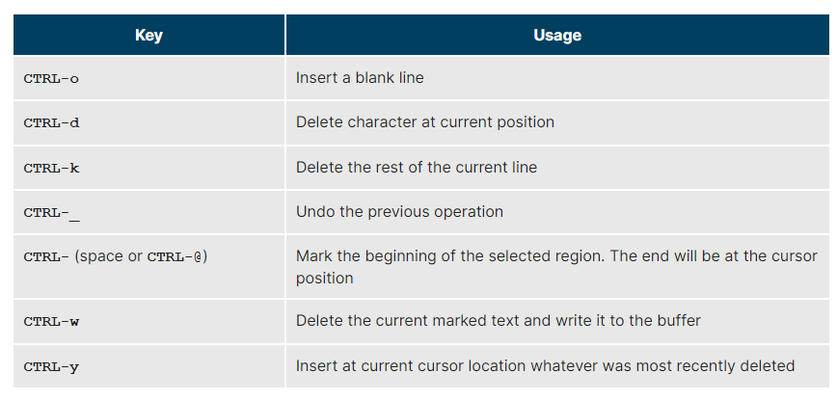

You have completed Chapter 11. Let’s summarize the key concepts covered:

* + - Text editors (rather than word processing programs) are used quite often in Linux, for tasks such as creating or modifying system configuration files, writing scripts, developing source code, etc.
    - nano is an easy-to-use text-based editor that utilizes on-screen prompts.
    - gedit is a graphical editor, very similar to Notepad in Windows.
    - The vi editor is available on all Linux systems and is very widely used. Graphical extension versions of viare widely available as well.
    - emacs is available on all Linux systems as a popular alternative to vi. emacs can support both a graphical user interface and a text mode interface.
    - To access the vi tutorial, type **vimtutor** at a command line window.
    - To access the emacstutorial type **Ctl-h** and then **t** from within emacs**.**
    - **vi** has three modes: *Command*, *Insert*, and *Line*. emacshas only one, but requires use of special keys, such as **Control** and **Escape**.
    - Both editors use various combinations of keystrokes to accomplish tasks. The learning curve to master these can be long, but once mastered using either editor is extremely efficient.

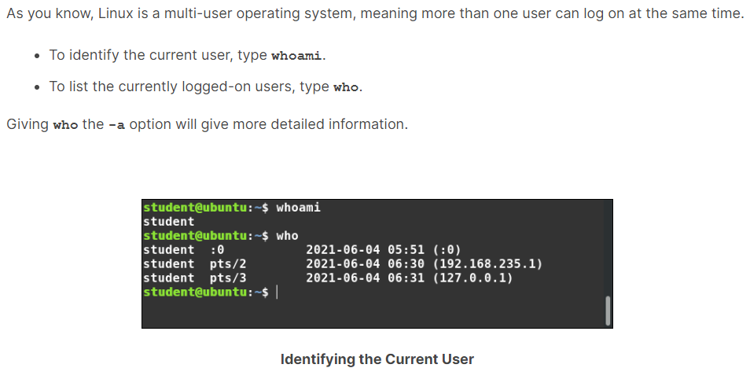

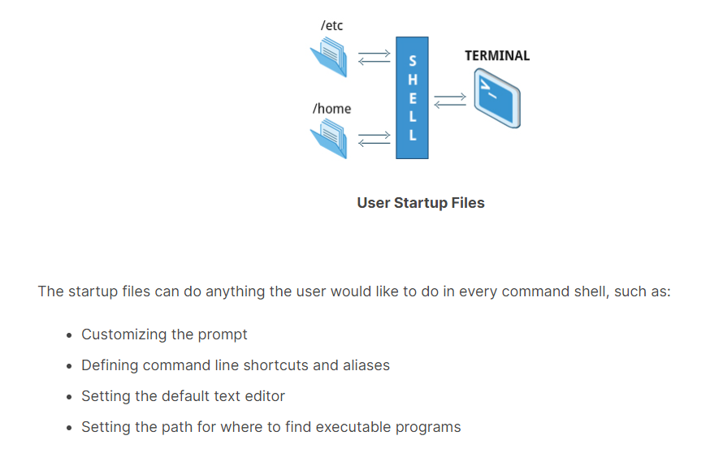

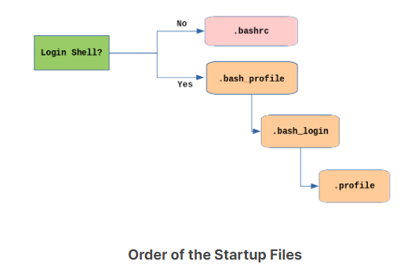

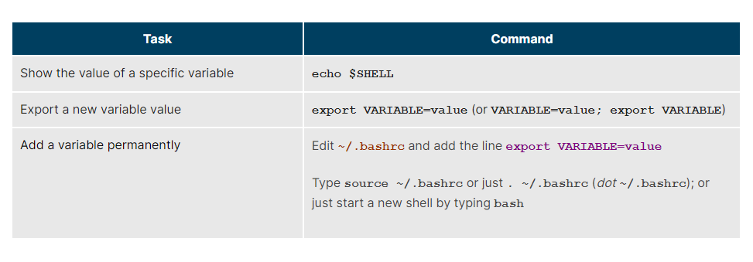

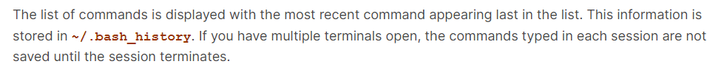

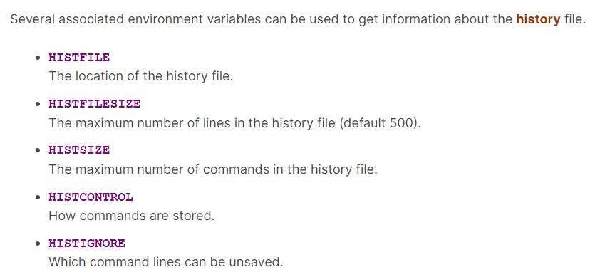

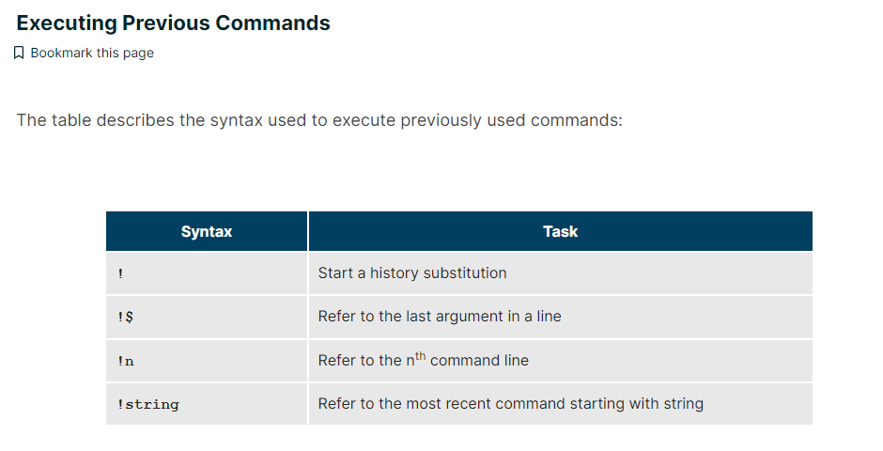

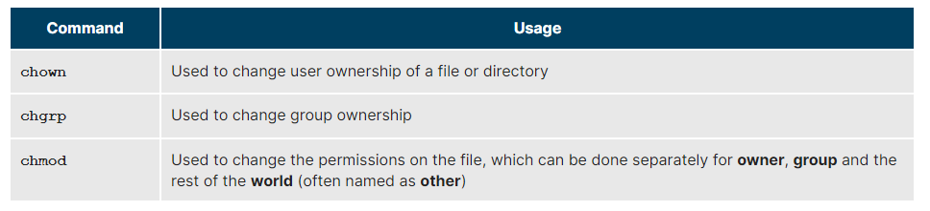

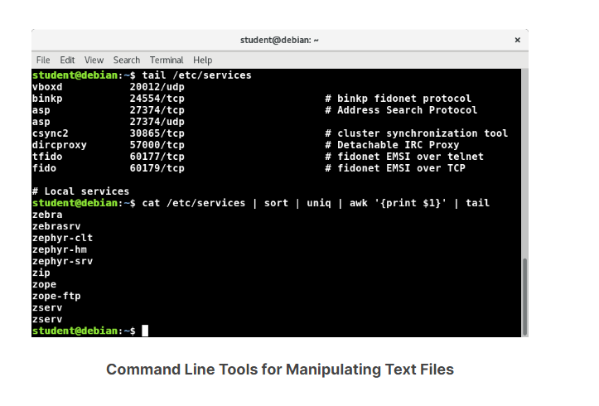

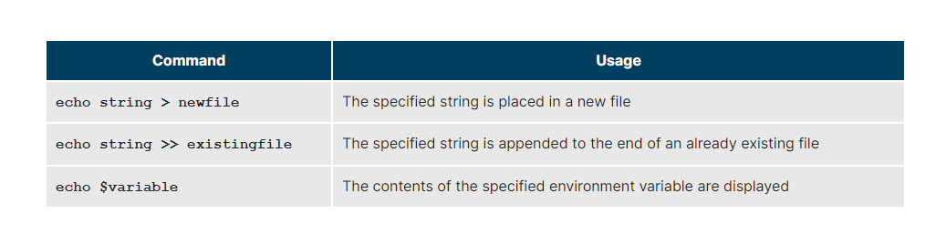

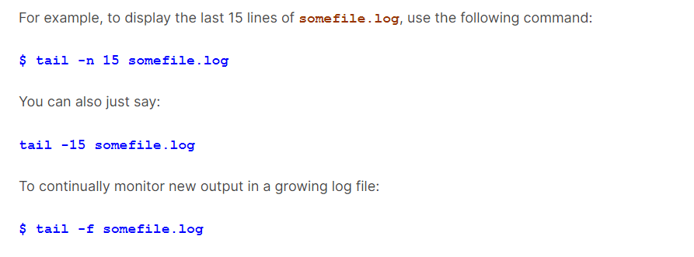

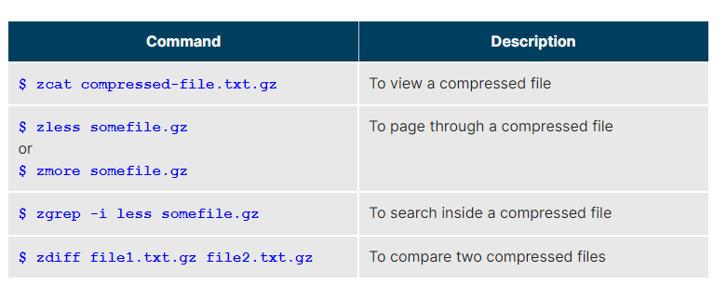

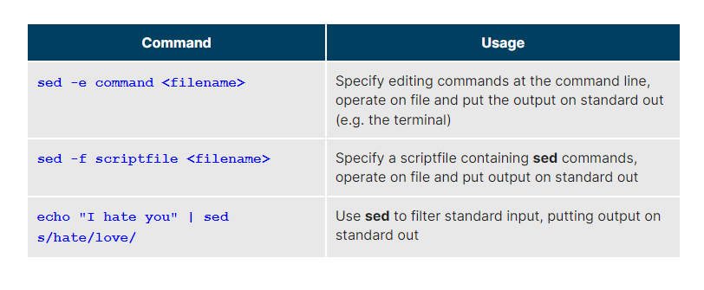

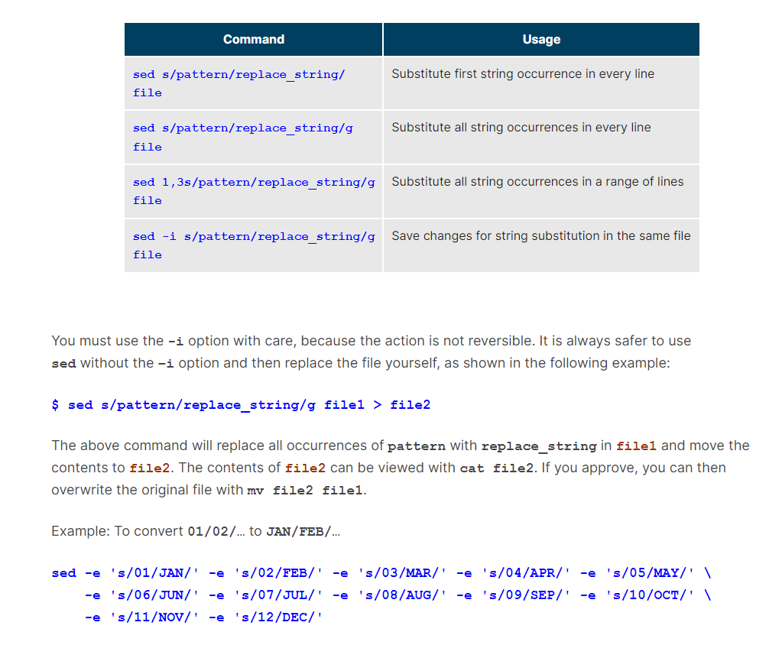

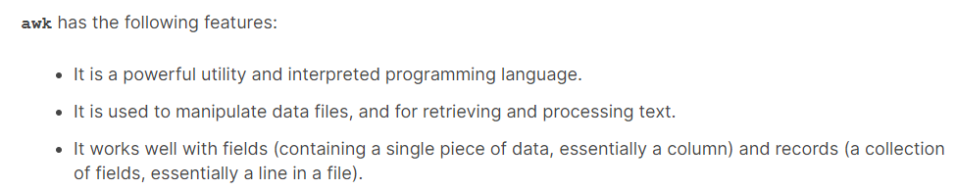

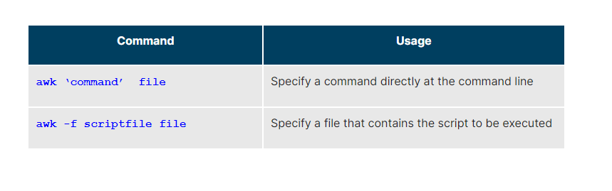

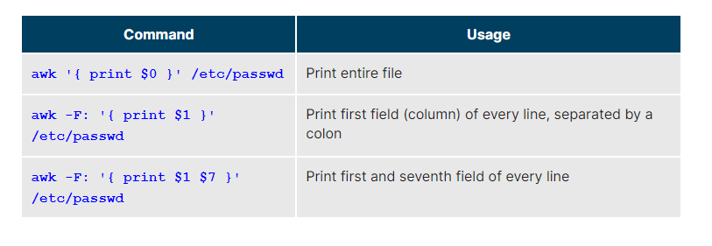

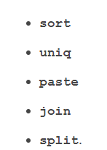

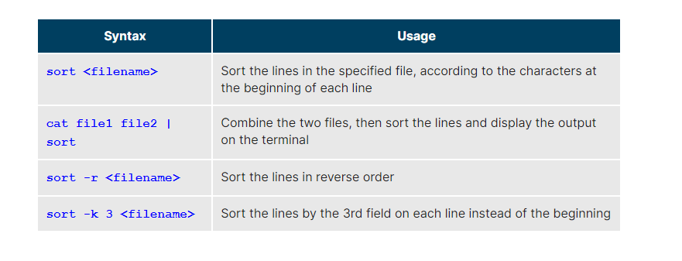

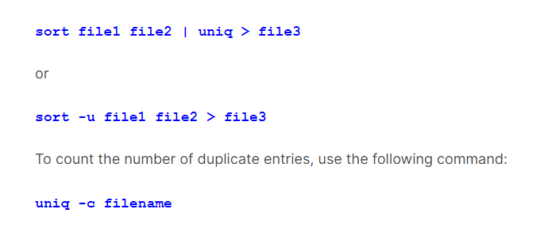

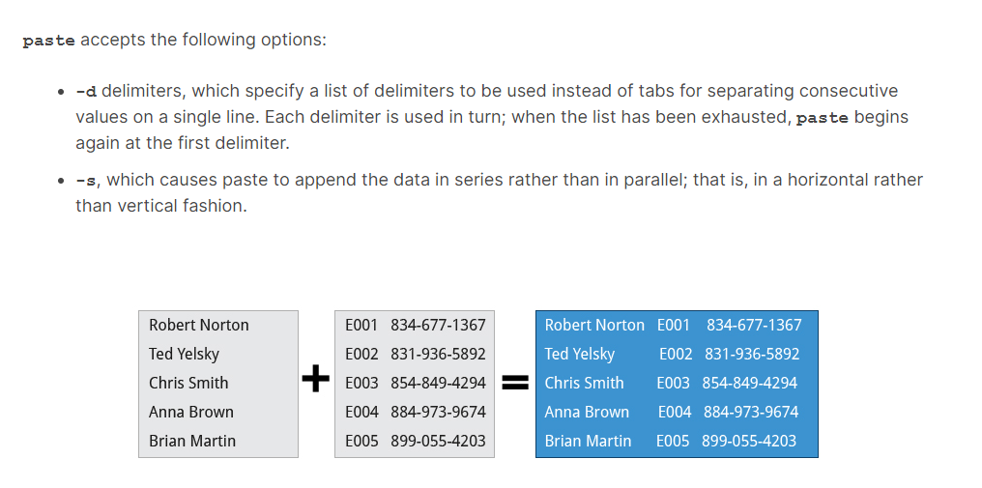

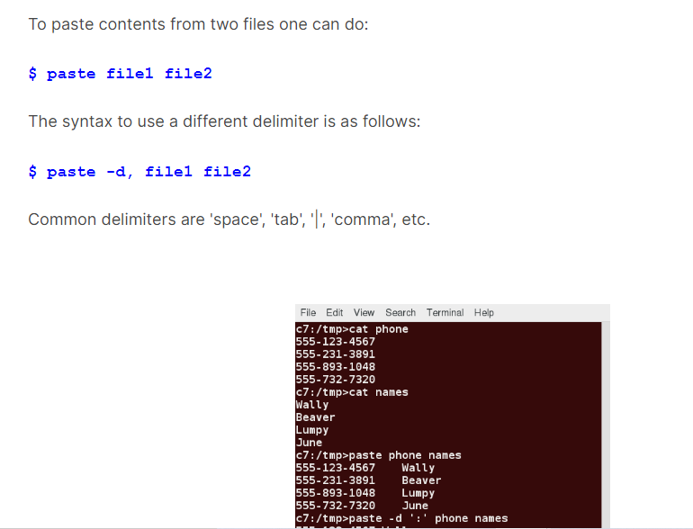

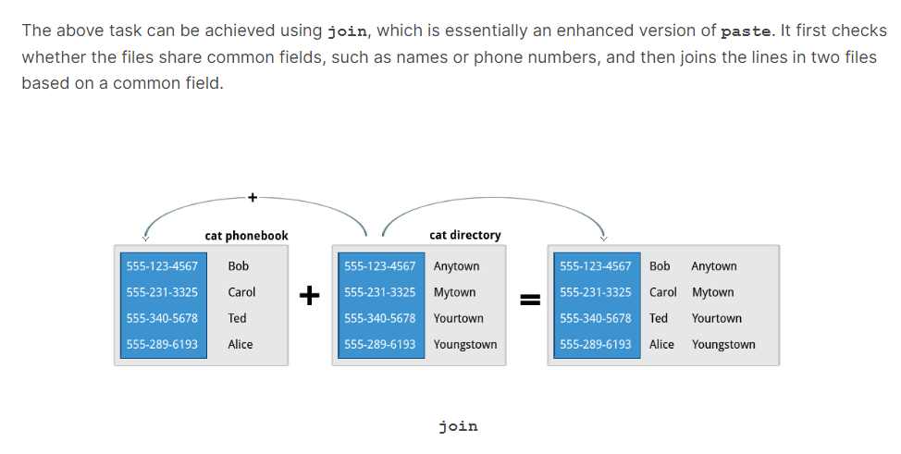

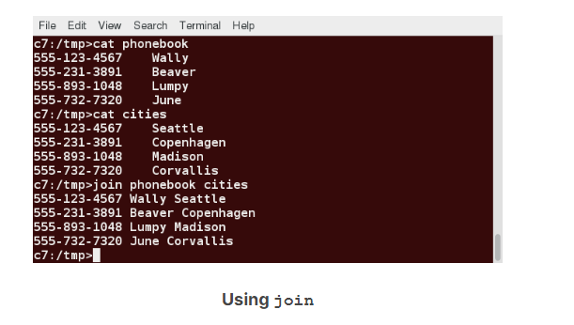

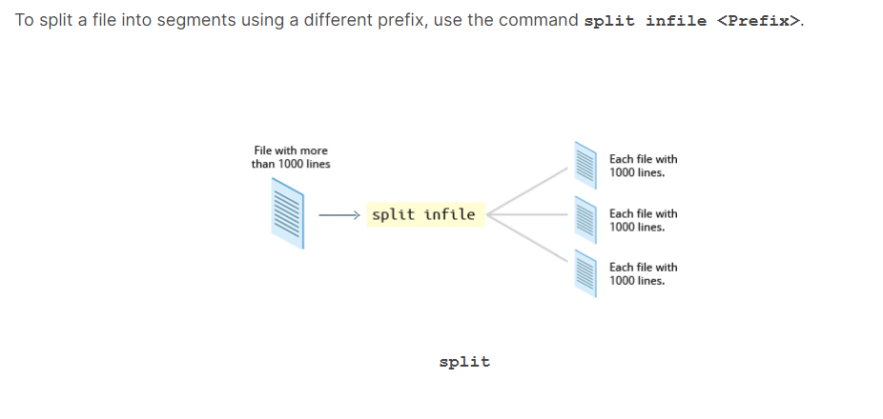

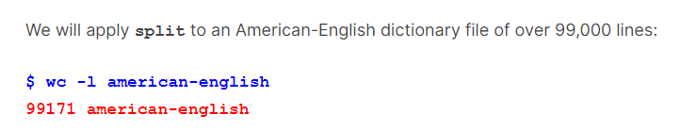

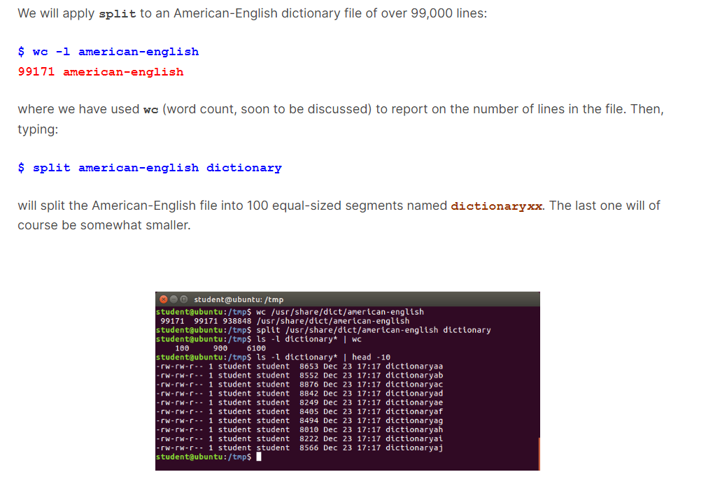

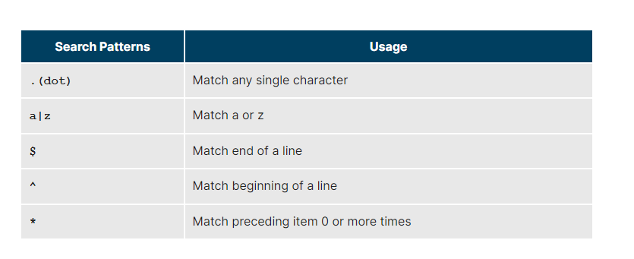

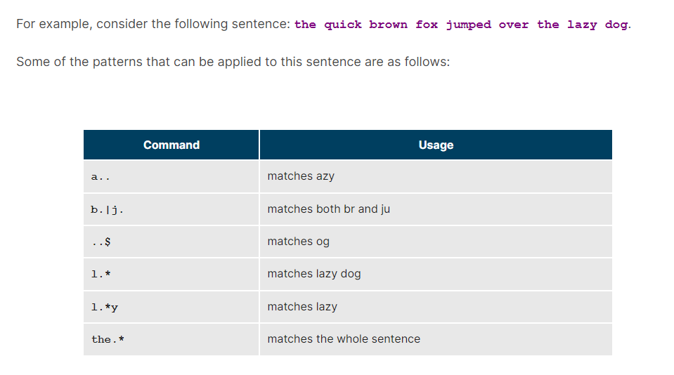

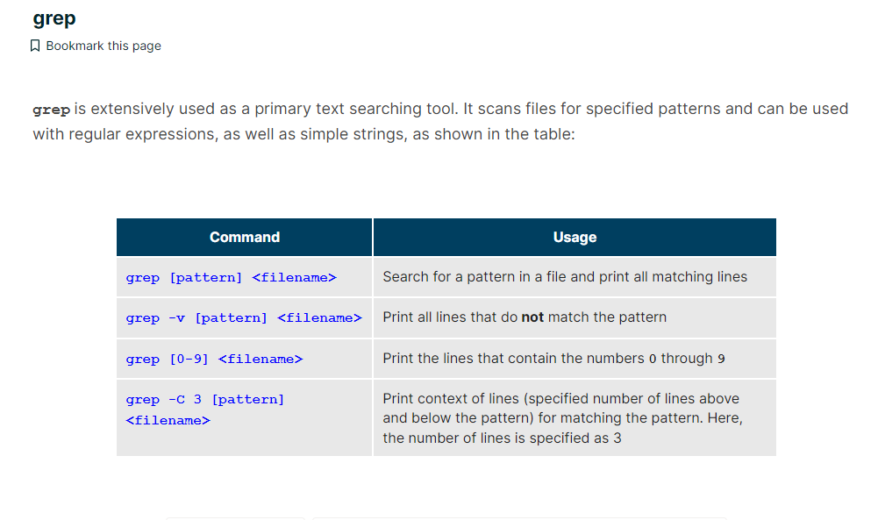

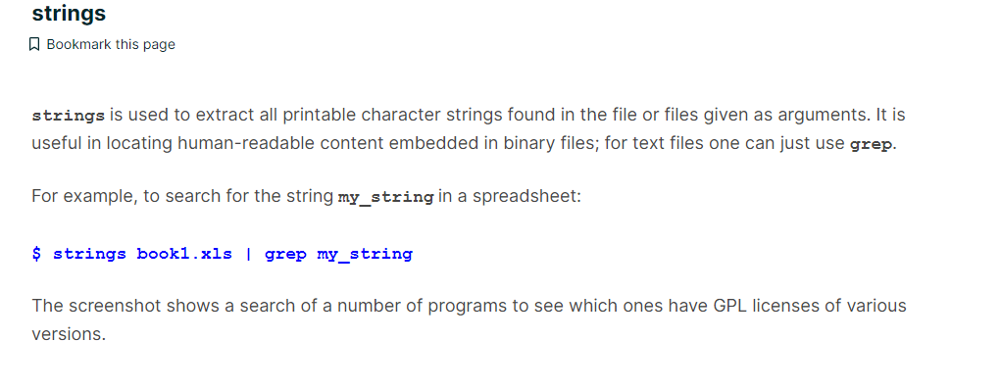

In this section, you will learn about some additional text utilities that you can use for performing various actions on your Linux files, such as changing the case of letters or determining the count of words, lines, and characters in a file.

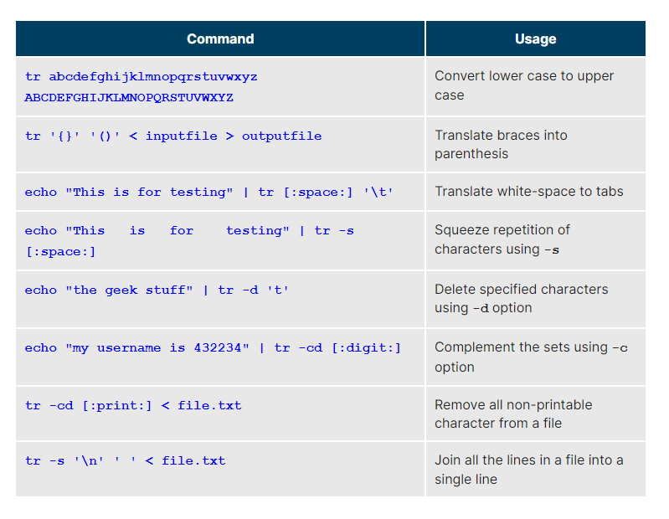

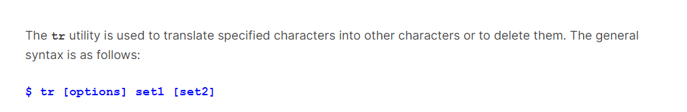

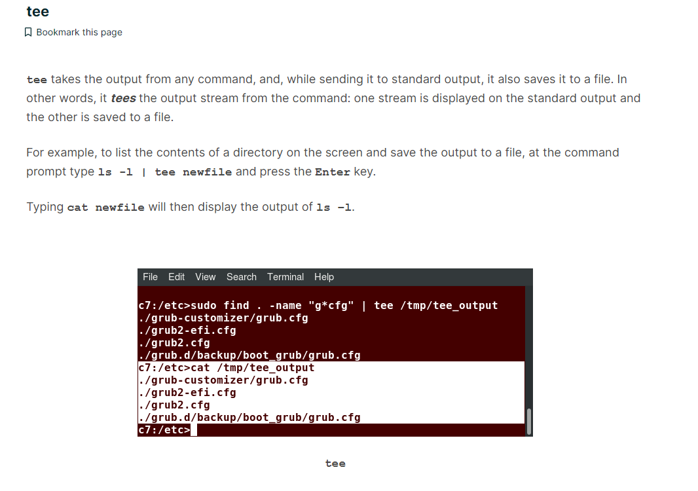

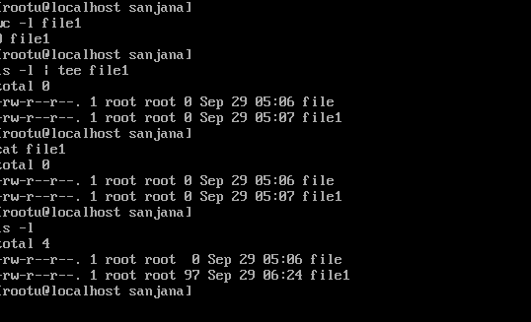

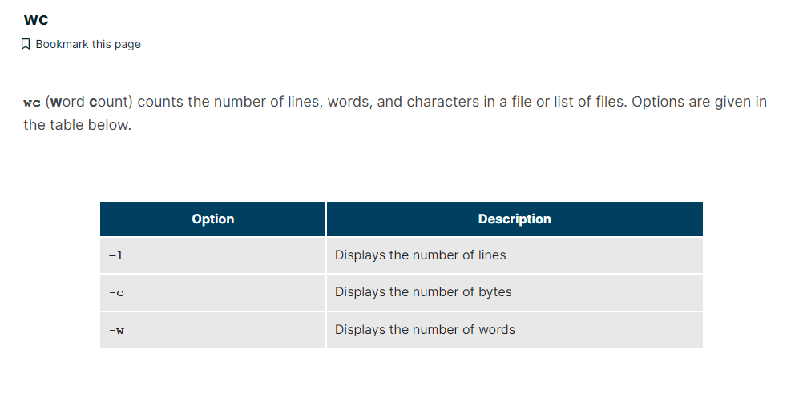

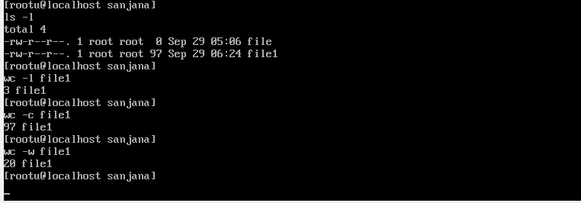

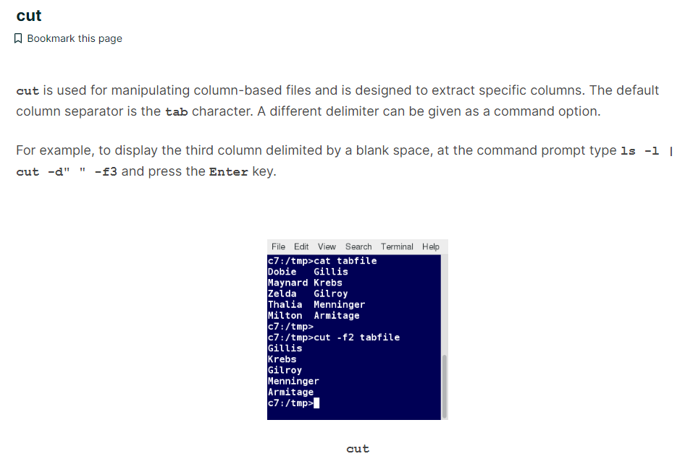

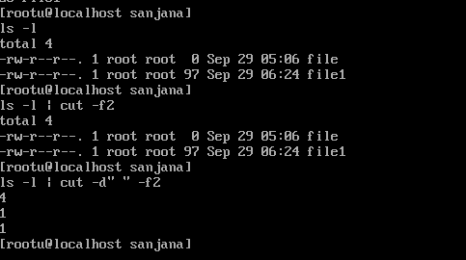

You have completed Chapter 13. Let’s summarize the key concepts covered:

* + - The command line often allows the users to perform tasks more efficiently than the GUI.
    - **cat**, short for concatenate, is used to read, print, and combine files.
    - **echo** displays a line of text either on standard output or to place in a file.
    - **sed** is a popular stream editor often used to filter and perform substitutions on files and text data streams.
    - **awk** is an interpreted programming language, typically used as a data extraction and reporting tool.
    - **sort** is used to sort text files and output streams in either ascending or descending order.
    - **uniq** eliminates duplicate entries in a text file.
    - **paste** combines fields from different files. It can also extract and combine lines from multiple sources.
    - **join** combines lines from two files based on a common field. It works only if files share a common field.
    - **split** breaks up a large file into equal-sized segments.
    - Regular expressions are text strings used for pattern matching. The pattern can be used to search for a specific location, such as the start or end of a line or a word.
    - **grep** searches text files and data streams for patterns and can be used with regular expressions.
    - **tr** translates characters, copies standard input to standard output, and handles special characters.
    - **tee** saves a copy of standard output to a file while still displaying at the terminal.
    - **wc** (word count) displays the number of lines, words, and characters in a file or group of files.
    - **cut** extracts columns from a file.
    - **less** views files a page at a time and allows scrolling in both directions.
    - **head** displays the first few lines of a file or data stream on standard output. By default, it displays 10 lines.
    - **tail** displays the last few lines of a file or data stream on standard output. By default, it displays 10 lines.
    - **strings** extracts printable character strings from binary files.
    - The **z** command family is used to read and work with compressed files.

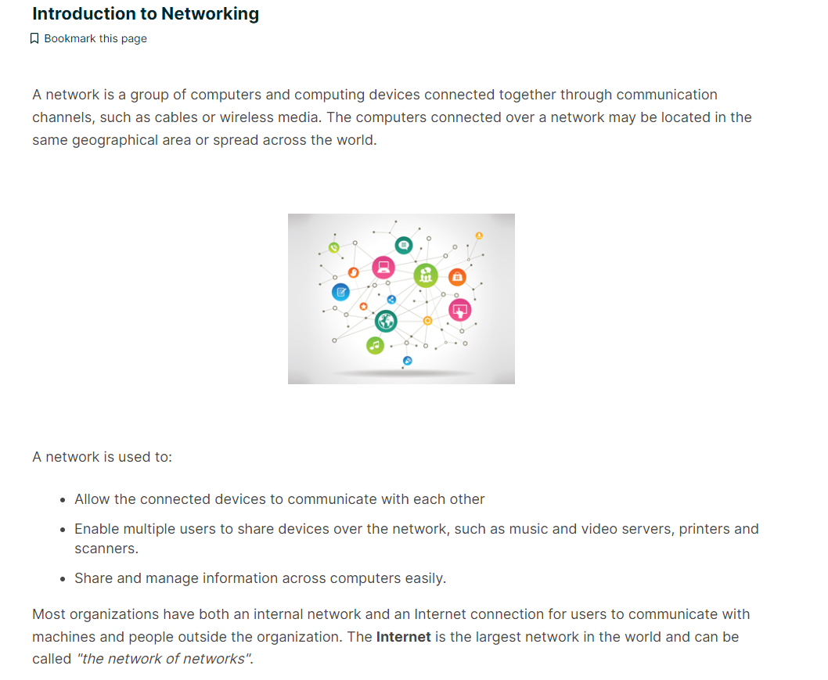

Devices attached to a network must have at least one unique network address identifier known as the **IP** (**I**nternet **P**rotocol) address. The address is essential for routing packets of information through the network.

